COMP 2003 Final Report
Contents
Main page 2
Introduction 2
Problem statement: (Aarju Shrestha) 2
Brief overview of project solution: (Aarju Shrestha) 3
Brief system requirements: (Aarju Shrestha) 4
Functional requirements 4
Non-Functional requirements 5
Our Client: (Marc Jones) 5
Project Management 5
Development methodology (agile): (Aarju Shrestha) 5
Risk assessment/mitigation: (Aarju Shrestha) 7
Client management/meetings: (Aarju Shrestha) 8
Project Schedule: (Marc Jones) 9
Sprint planning/execution: (Marc Jones) 10
Detailed System Design (Ed) 12
Diagrams 12
Wireframes and explanations 12
Improved wireframes 15
Game flow charts (Ed) 22
Entity relationship diagram (Ed) 25
User Stories: (Marc Jones) 26
Site Flow 26
Integration methods 28
Firebase Authentication: (Aarju Shrestha) 28
Firebase Firestore Database: (Aarju Shrestha) 29
Multiplayer: (Aarju Shrestha) 31
AI integration: (Marc Jones) 32
Game Development: (Marc Jones) 38
Worm game mechanics (Ed) 44
Sabotage Mode 45
Playtesting and Feedback 45
Frontend Design and Implementation: 46
Design Language: (Aarju Shrestha) 46
Page-Level Structure: (Aarju Shrestha) 47
Responsive Design: (Aarju Shrestha) 47
Key UI Components: (Aarju Shrestha) 47
Quality Assurance(Nicholai Baes) 50
Limitations and Future work (Nicholai Baes) 51
Conclusion(Nicholai Baes) 51
References 52
Appendix 52

Main page
- Client Name
- Group Name
- Table of team members and role in group/responsibilities

Introduction

Problem statement: (Aarju Shrestha)
Traditional approaches to teaching cyber-security concepts in academic settings often struggle to maintain student engagement over the duration of a module. Lecture-based delivery of topics such as network security, cryptography, digital forensics, and threat analysis tends to be inherently passive, requiring students to absorb substantial theoretical content with limited opportunity for active participation or competitive collaboration. Research in educational technology consistently demonstrates that students retain and apply technical knowledge more effectively when they encounter it through interactive, experiential contexts rather than through passive receipt of information.
Purpose-built interactive platforms tailored specifically to cyber-security education are scarce. Generic quiz tools such as Kahoot or Quizlet can deliver factual recall exercises but offer no mechanism for dynamic question generation, no integration with subject-specific tooling, and no game mechanics beyond simple scoring. Gamified platforms that do exist in the cyber-security space are typically aimed at professional training audiences, are prohibitively expensive for classroom deployment, or require significant technical setup beyond the reach of a typical university module.
Our client, Dr Rory Hopcraft, identified this gap directly from his experience as a Lecturer in Cyber Security at the University of Plymouth. He required a platform that could deliver curriculum-relevant trivia questions to students in a game-driven, team-competitive format, motivate continued engagement through escalating game mechanics, and allow a teacher to create, configure, and launch a session from within a standard classroom environment without specialist technical knowledge or expensive infrastructure. Critically, the system had to be flexible enough to serve any cyber-security topic, not just a fixed set of pre-authored questions.

Brief overview of project solution: (Aarju Shrestha)
Capture the Flag is a web-based multiplayer educational game platform built around a repeating loop of trivia questions followed by Unity WebGL mini-games. The platform is designed to be used within a live classroom session: a teacher creates a game room, shares a six-digit PIN with students, and students join from their own devices. Teams compete by accumulating points across multiple quiz-then-game rounds, with final scores synchronised in real time to a shared scoreboard visible to the teacher.
The platform is divided into two distinct user-facing flows. The student flow progresses through: Google authentication, PIN entry, team and role selection, a waiting lobby, and then the game itself. The teacher flow provides session creation and PIN management, AI-driven question generation with a human review editing step, question upload to the session database, game launch control, and live score monitoring. These flows are entirely separate at the interface level, with access control enforced through role attributes stored in the database.
The entire backend is provided by Google Firebase. Firebase Authentication handles identity management through Google OAuth 2.0, and Cloud Firestore provides document storage and the real-time listener API used for live score synchronisation and waiting room coordination. This architecture means the game itself requires no custom application server; all player requests go directly from the browser to Firebase via the Firebase Web SDK, which significantly simplifies deployment and eliminates a major potential point of failure.
The AI question generation subsystem is the only component that requires a locally running server. It uses a Node.js and Express backend to relay prompts from the teacher interface to a locally hosted Ollama instance running the Gemma3-4b language model. Generated questions are returned as structured JSON, cleaned and validated server-side, and then made available for teacher review and editing before being uploaded to the Firestore question bank for the session.

Brief system requirements: (Aarju Shrestha)

Functional requirements
- Students must be able to authenticate using their Google account; a persistent profile must be created in the database on first login.
- Teachers must be authenticated separately from students; the system must distinguish between the two roles and redirect accordingly.
- The system must generate a unique six-digit PIN for each game room; students must be able to use this PIN to join the correct session.
- Students must be able to select a team (A or B) and a named role (Scout, Warrior, Flag Carrier, or Defender) before the game begins.
- The game must serve a set of four trivia questions per round, each with a visible ten-second countdown timer, loaded from the Firestore question bank for the active session.
- Each correct answer must increment the player’s score multiplier by 0.25x and add five seconds of bonus time to the upcoming mini-game.
- After each question round, a mini-game briefing screen must display the player’s accumulated trivia points and multiplier before the mini-game launches.
- The Unity WebGL mini-game must communicate its final score to the host page; this score must be multiplied by the accumulated multiplier, combined with trivia points, and submitted to Firestore as the player’s round contribution.
- Both team scores must update in real time across all connected clients without requiring a page refresh.
- The teacher must be able to launch the game for all connected students simultaneously; all students in the waiting room must transition to the game page automatically.
- The teacher must be able to generate question packs via the AI tool, review and edit them, and upload them to the session’s question bank.
- The game loop must continue repeating (quiz then mini-game) until fewer than four questions remain in the question bank, at which point the session ends.

Non-Functional requirements
- The platform must be accessible via a standard modern web browser (Chrome, Firefox, Edge) without requiring installation of browser plugins or extensions.
- Authentication must use Google OAuth 2.0 managed by Firebase Authentication; no passwords are stored by the system.
- All persistent data including user profiles, session rooms, match records, and scores must be stored in Google Cloud Firestore.
- The interface must be responsive and usable on desktop monitors and tablet-sized screens. Mobile phones are a secondary target.
- Concurrent player sessions must be isolated at the Firestore data level; no cross-contamination of scores or questions between rooms is permissible.
- Score updates from concurrent players must be handled atomically to prevent race conditions.
- The system must handle the teacher launching the game for all waiting players with a real-time latency of under three seconds from status change to player redirect.

Our Client: (Marc Jones)
This project is made especially for our client Dr Rory Hopcraft (Lecturer in Cyber Security, University of Plymouth). He has closely worked alongside our group throughout this project.
Due to Dr Hopcraft’s speciality in Computer Science and experience in teaching students, he has been reasonable yet ambitious when it comes to setting expectations for us to meet. He has remained an immensely reliable client and has been quick to respond upon reaching out. Alongside this, he has shown us great respect, remaining positive and approachable to us.

Project Management

Development methodology (agile): (Aarju Shrestha)
The team adopted an Agile development methodology, drawing specifically on Scrum-style sprint cycles. Agile was chosen over a Waterfall model for several reasons rooted in the nature of this project. The client’s requirements were deliberately left open-ended at the outset; Dr Hopcraft had a clear vision of the educational outcome he wanted but was open to iteration on how the system should achieve it. This ambiguity is well-suited to iterative delivery, where each sprint produces a demonstrable increment and feedback can be incorporated before the next sprint begins rather than being deferred to a post-delivery review.

Sprints ran for two to three weeks each. At the start of each sprint, the team held a planning session to review the backlog, assign tasks based on each member’s technical strengths, and agree on acceptance criteria for each item. The task backlog was maintained on a shared Trello board, with items represented as cards carrying checklists, assignees, and status labels. Completion of a task was communicated through the group messaging channel and marked on the board, keeping all team members informed of current progress without requiring daily synchronous standups.

At the end of each sprint, a formal review was held with the module supervisor, Dr Ji-Jian Chin. These meetings served as a structured accountability checkpoint: the team would demonstrate the working increment, Dr Chin would provide feedback, and any issues or blockers that had emerged during the sprint would be surfaced and discussed. Following the sprint review, the team held an internal meeting to translate feedback into concrete next-sprint tasks and re-prioritise the backlog accordingly.

Version control was managed through the group’s shared GitHub repository hosted under the University of Plymouth GitHub organisation. Each team member worked on a personal branch for their current feature, pushing to the remote repository regularly. Pull requests were used to merge completed features into the main branch, providing an informal peer review step and ensuring the main branch always represented the latest stable build. Commit messages were written descriptively to make the history legible to all team members.

Client meetings with Dr Hopcraft were held at key milestones rather than at every sprint boundary, typically after a significant new feature had been integrated and was ready to demonstrate. Dr Hopcraft provided feedback at three sessions during the project: an early demo of the authentication and PIN join flow, a mid-project demo of the full quiz-and-game round loop, and a final walkthrough of the complete teacher dashboard. His feedback at each session directly influenced subsequent sprint priorities.

- Project planning material(content from semester 1)

Risk assessment/mitigation: (Aarju Shrestha)
A risk register was maintained throughout the project to identify, evaluate, and plan mitigations for threats to successful delivery. Risks were assessed on two dimensions: likelihood and impact. The following table presents the key risks identified and the mitigations applied.
Risk | Likelihood | Impact | Mitigation
Firebase security rules misconfigured– unauthorised data access | Medium | High | Firestore security rules applied per collection during development; tested with unauthenticated browser sessions to verify rules block access
AI model producing malformed JSON – questions fail to load | High | Medium | Two-stage JSON cleanup pipeline implemented in Server.js; brace extraction removes all text outside the main object; tested with 15+ diverse prompts
Unity WebGL build failing to communicate scores to the host page | Medium | High | window.postMessage API used for cross-frame messaging; validated with console logging; a custom DOM event (unityGameOver) decouples reception from scoring logic
Concurrent Firestore writes causing score corruption under load | Medium | High | Firestore increment() atomic field transform used for all score updates; eliminates read-modify-write race condition
Team member unavailability due to overlapping coursework deadlines | High | Medium | Subsystems scoped independently; each team member’s area can progress without blocking another; tasks documented on Trello so others can pick up if needed
Cross-browser CSS rendering differences breaking the UI layout | Medium | Low | Standard CSS properties used throughout; tested on Chrome, Firefox and Edge; flexbox used for layout rather than proprietary grid extensions
localStorage state lost between pages if user clears browser storage | Low | Medium | Defensive null checks on all localStorage reads; pages redirect to join.html if critical values (roomId, uid) are missing
Ollama AI server not running when teacher attempts question generation | Medium | Low | Server.js returns an appropriate error response; the teacher interface displays an error message rather than hanging
Figure 1 – Risk register

Client management/meetings: (Aarju Shrestha)
Dr Rory Hopcraft served as the primary client throughout the project. Engagement with the client was structured around three formal demonstration sessions, supplemented by asynchronous communication via email when clarification was required between sessions. Each formal session followed a consistent format: the team demonstrated the current state of the product, the client provided feedback, and action points were recorded and carried into the next sprint backlog.
The first client session demonstrated the authentication and PIN join flow. Dr Hopcraft confirmed the Google Sign-In approach was acceptable for a university context where all students have institutional Google accounts, and requested that the teacher sign-in path be visually distinct from the student path rather than a post-login role check. This was implemented as separate buttons on login.html, each triggering a different sign-in function.
The second client session demonstrated the complete quiz-and-game round loop. Dr Hopcraft observed that the original design combined AI question generation directly with the session setup flow, creating a confusing multi-step process. He requested these be separated into distinct tools within the teacher dashboard, so that question generation could be done in advance and the session launch remained a simple two-step process (create room, launch game). This structural change was implemented before the next sprint.
The third client session was a full walkthrough of the complete system. Dr Hopcraft confirmed the product met his original brief. His remaining feedback related to polish items: a visible PIN reminder on the game page (subsequently added as the session PIN display on game.html), and clearer labelling on the PIN entry page for students unfamiliar with the concept.

- Reflection of development plan vs actual development

Project Schedule: (Marc Jones)
As a group, we tried our best to follow a schedule that I had outlined for us towards the start of our project. We tried to stay true to this to the best of our ability but due to other circumstances such as coursework pieces and priority shifts, we eventually fell behind this process. Our original plan is as follows:
Date | Main goals/Expectation
02/02/26 | Have basic working build implemented for one user
16/02/26 | Implement AI questioning and first fully developed game
02/03/26 | Host on university servers. Have multiple demo users available
16/03/26 | Implement host functionality (score views and player management)
30/03/26 | Implement custom users via account creation
20/04/26 | Track users play data including scores
PROCEEDING | Refinement + functional user testing
Figure 1 – Second semester sprint plans
Following is a visual representation of this in the form of a Gantt chart. This has been made via GPT-5.1 with the input from Figure 1.
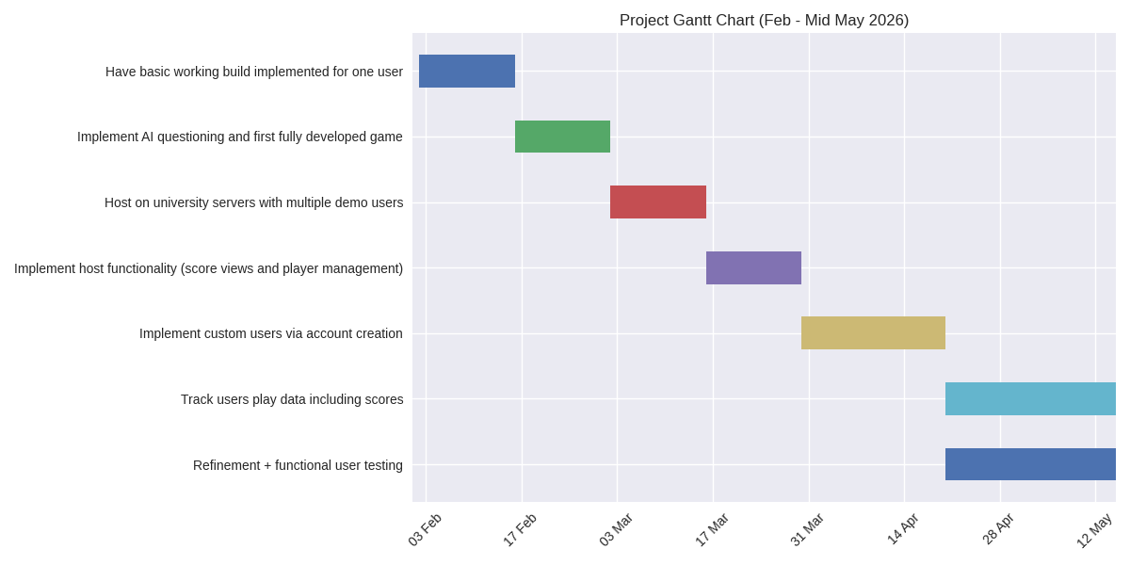
Figure 2 – Sprint plans diagram
The initial plan made was too single task focused for our group and development approach. We quickly realised that it would be better to handle these tasks (for example the ‘AI questioning’ or ‘host functionality’ individually and collate these later to create one solid solution.
Whilst we did attempt to work on the same items at the same time originally, we had difficulties with conflicting work where certain productions were overlapping with someone else’s work. Breaking our work up by building a basic framework and having people work on separate areas worked seamlessly. This also helped to keep consistency in design – especially when wireframes and designs had been made.

Sprint planning/execution: (Marc Jones)
In alignment with our development approach, we worked on our website in cycles. These spanned from two to three weeks (more on this in ‘Development Methodology’).
We were given the opportunity to have planned sprint meetings with our module leader Dr Ji-Jian Chin (Lecturer in Computer Science, University of Plymouth). In these meetings we would discuss our progress. This would be presented to Dr Chin and we would receive his feedback. These also provided us with an opportunity to present any roadblocks we faced and ask for support on how to address them. These proved extremely useful in guiding us in the right direction along with providing motivation to complete our work.
We would then hold a meeting in the following days to discuss exactly what our next steps would be and assign work based on each individual’s skills. Evidence of these meetings can be found in the references (under ‘meeting minutes’). Typically, these would be held within one to two days of our sprint meetings.
Future sprint planning would happen here, making sure everyone is accepting of their development role and future plans. Discussion on the direction of the website and future hurdles would be discussed here and attempted to resolve amongst ourselves.
These sprint plans would be recorded and updated appropriately in our shared Trello board. Here, we can create checklists as a sort of ‘to-do’ list for the coming weeks. Each item would detail what tasks need to be completed alongside which member is assigned to it.
Upon completion of the tasks, we would place a tick off the relevant card, signifying its completion. Would then also communicate this with the others through a shared group message to keep everyone as up to date.
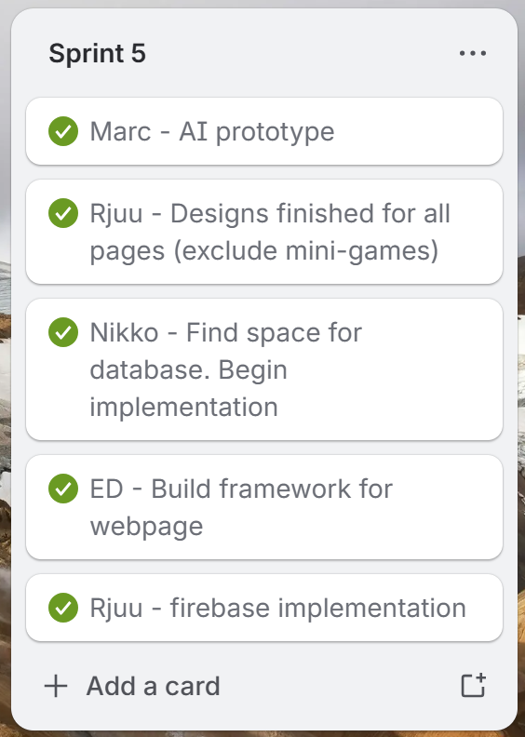
Figure 1 – Completed sprint example
When planning our sprints, we attempted to assign work around each members preferences and speciality. This allowed us to work on areas that we feel comfortable and confident with to produce the best outcome possible. Following is a rough breakdown of each of our strengths and responsibilities:

Name | Strengths/background | Responsibility
Marc | Game design/development  Web based game creation | Mini game creation  AI implementation  Game loop
Aarju | HTML  Design | Frontend structure  Website design  Data storage
Edward | Cyber Security  Game development | Mini game creation  Multiplayer implementation
Nicholai | Cyber Security  Networks | Sound design  Data storage  Accessibility Features
Figure 2 – Work breakdown per person
As shown in this table (figure 2), we were mostly able to stick to our backgrounds for this project. There are a few examples of individuals working outside of their area of expertise, but this provided us with a great way of expanding our knowledge of computing principles and share this new-found knowledge with the group for further support, not just with this project but also in our academic careers.

Detailed System Design (Ed)

Diagrams

Wireframes and explanations
Puzzle Interdependence System
Example Workflow
text
Security Analyst
↓ (discovers suspicious IP in phishing email)
Network Tracker
↓ (locates infected device on network map)
Code Breaker
↓ (repairs corrupted access script from device)
Systems Operator
↓ (deploys patch and quarantines device)

Key Interdependence Mechanics
- Information Sharing: Critical clues are distributed across different roles
- Sequential Unlocking: Some actions require multiple players to complete prerequisites
- Resource Management: Limited "admin privileges" that must be strategically allocated
- Time Pressure: Simultaneous puzzles that must be coordinated under time constraints
Technical Specifications

Visual Design
Interface Style: Dark theme with neon accents (cyber aesthetic)
Layout: Four distinct but connected panels showing:
- Network visualization map
- Code editing environment
- Security monitoring dashboard
- System control center
Old initial wireframe Overview
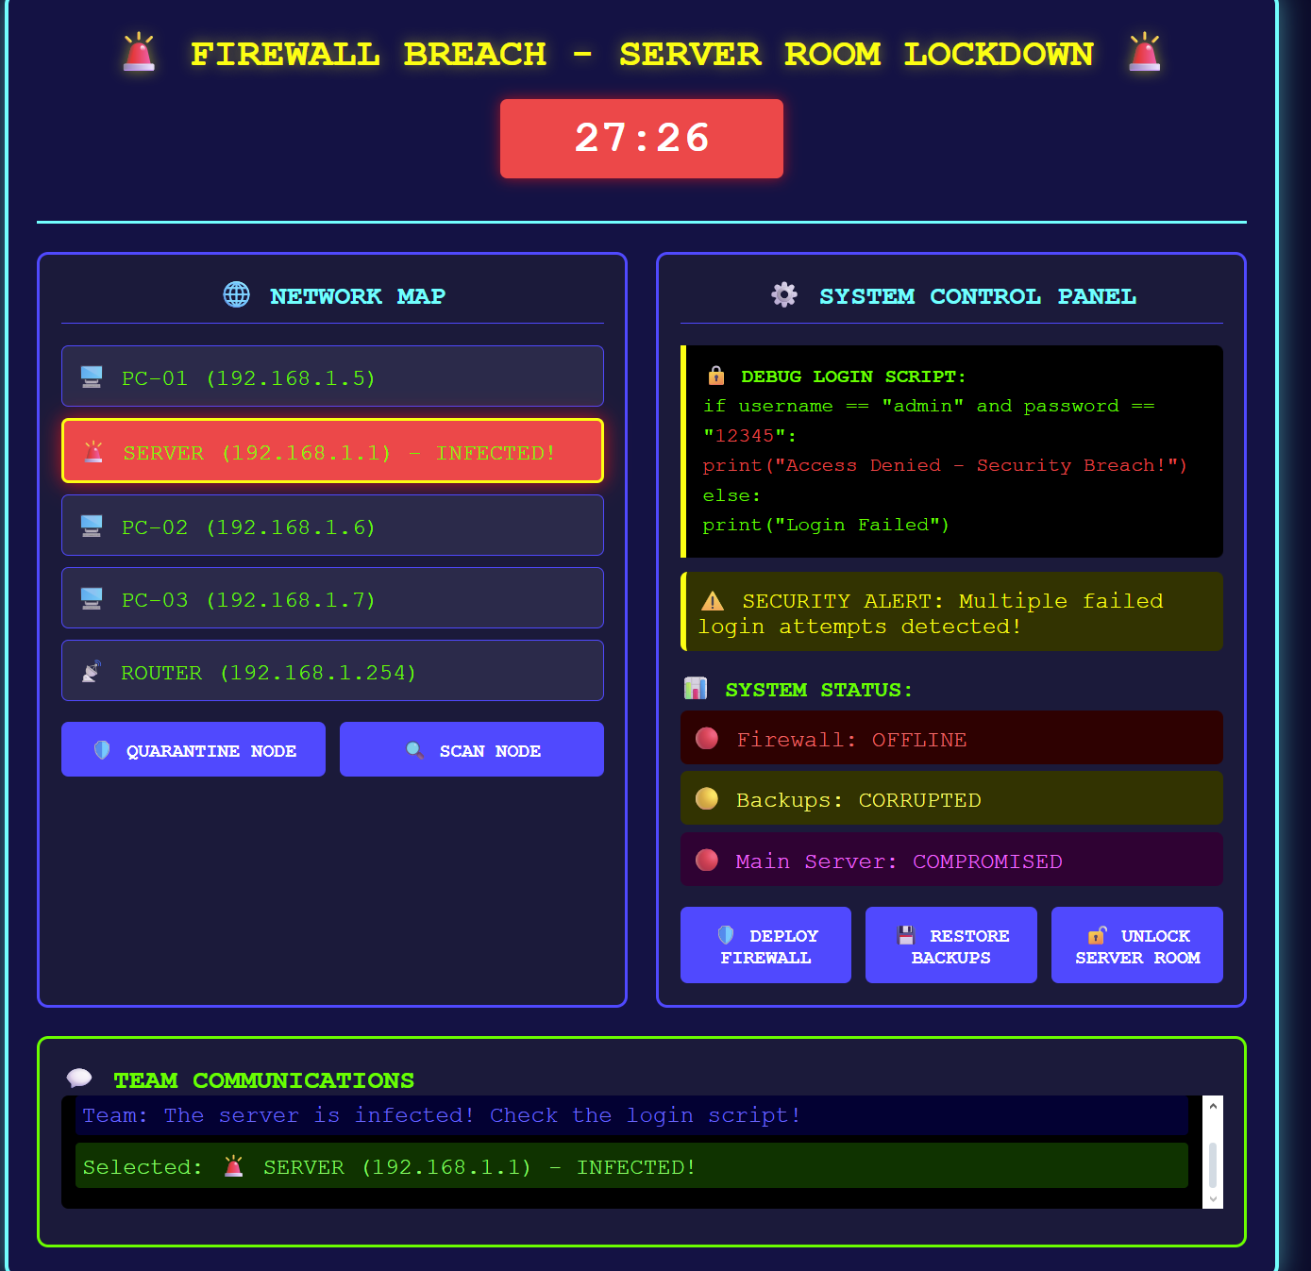
Technical Requirements
- Network: LAN connectivity for 4 players
- Visual: Clear distinction between role-specific interfaces
- Audio: Tense background music with security alert sounds
- Data: Shared game state with role-specific information filtering

Educational Value
Curriculum Alignment
- Computer Science: Networking, cybersecurity, programming basics
- Mathematics: Logical reasoning, pattern recognition, problem-solving
- Collaborative Skills: Communication, teamwork, role specialization
Learning Outcomes
- Understand basic network infrastructure
- Recognize common cyber threats
- Develop debugging and problem-solving skills
- Practice clear technical communication
- Experience coordinated team-based problem solving

Key Features & Innovation
Unique Selling Points
"It makes different IT concepts into an exciting race against time where every team member's contribution is important to success."
Innovation Highlights
- Role Specialization: Each player has unique tools and responsibilities
- Authentic IT Workflow: Mirrors real-world cyber incident response
- Progressive Difficulty: Puzzles scale from basic to advanced concepts
- Instant Feedback: Real-time consequences for actions and decisions

Comparable Games & Positioning
Similar Titles
- Keep Talking and Nobody Explodes (communication-focused puzzle solving)
- We Were Here (asymmetric information sharing)
- Hacknet (cyber security theme and interface)
Differentiation
- Specifically designed for GCSE educational requirements
- Four distinct specialized roles (vs. general collaboration)
- Curriculum-aligned IT and cybersecurity content
Classroom-friendly time limit and complexity

Improved wireframes
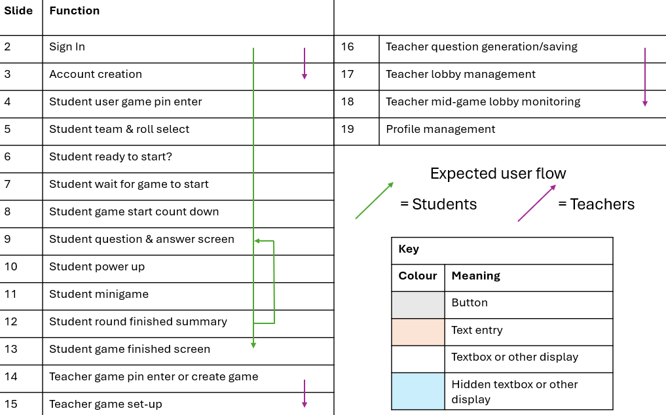
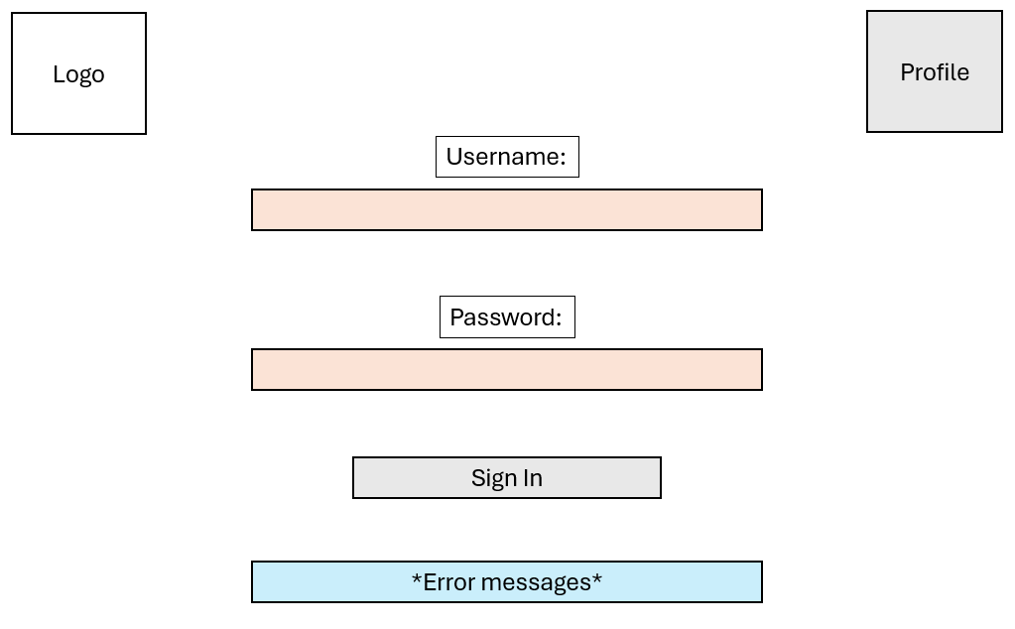
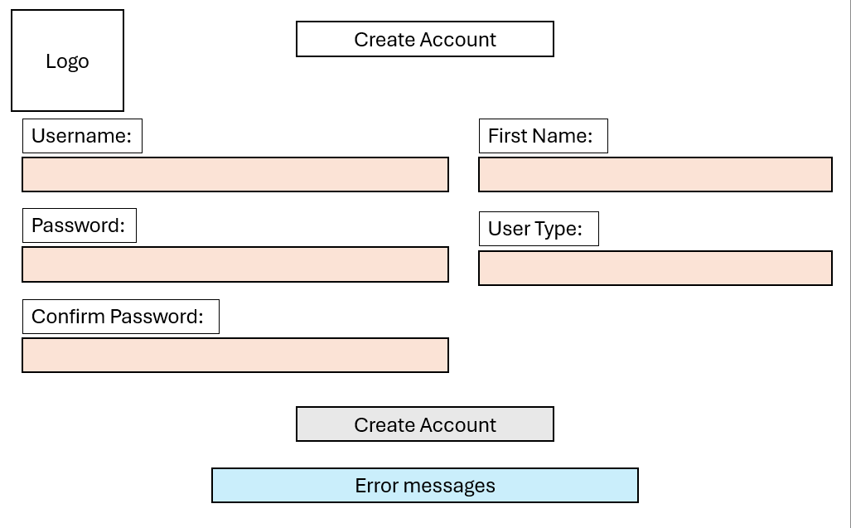
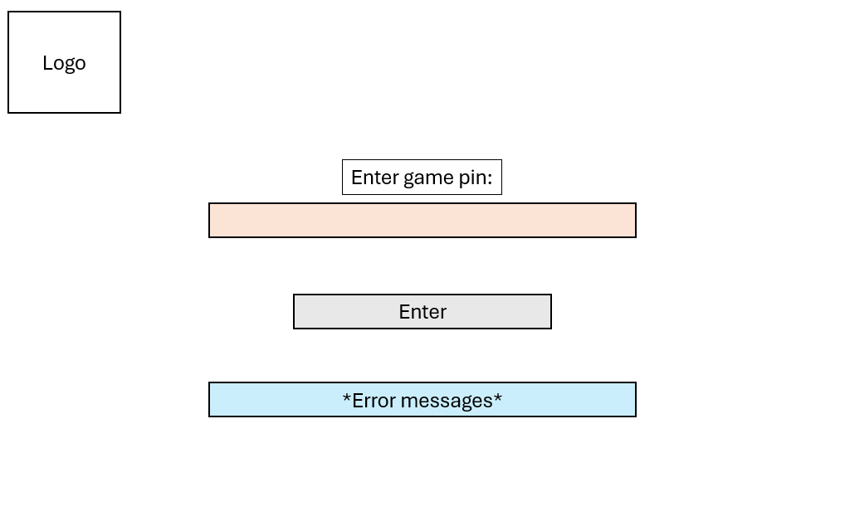
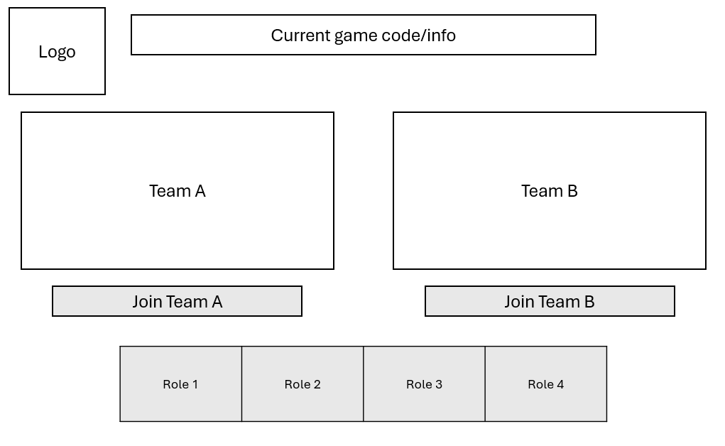
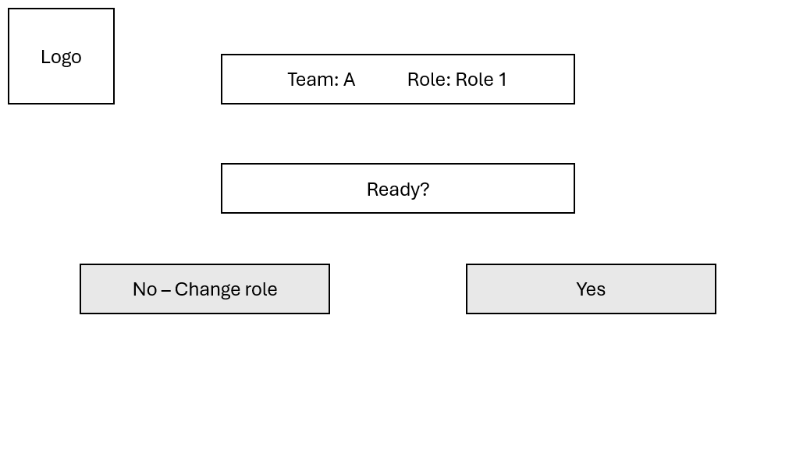
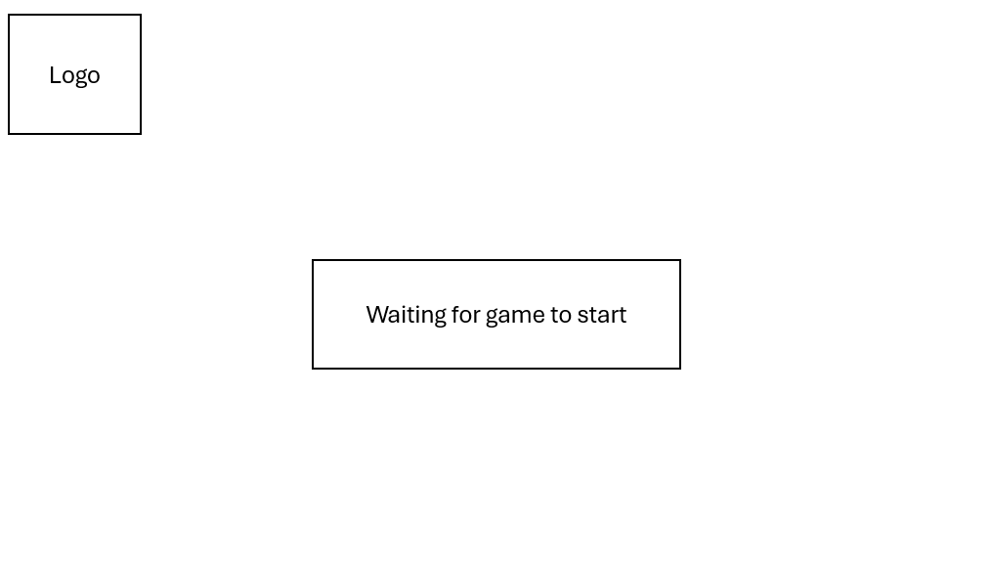
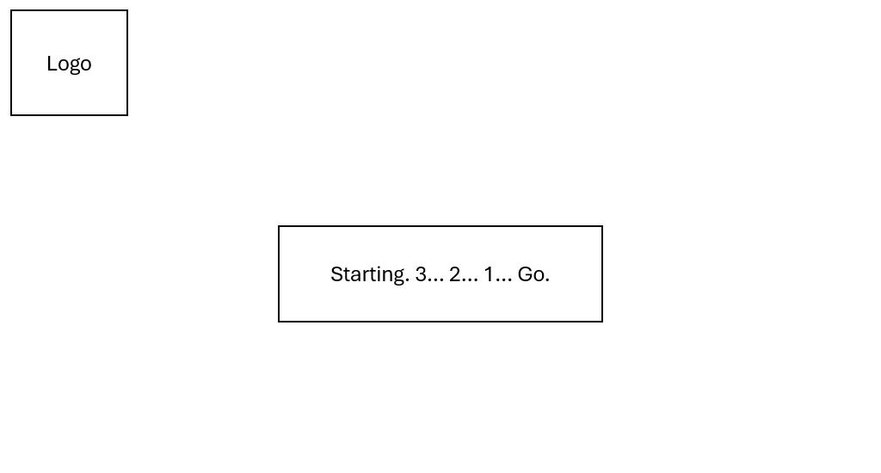

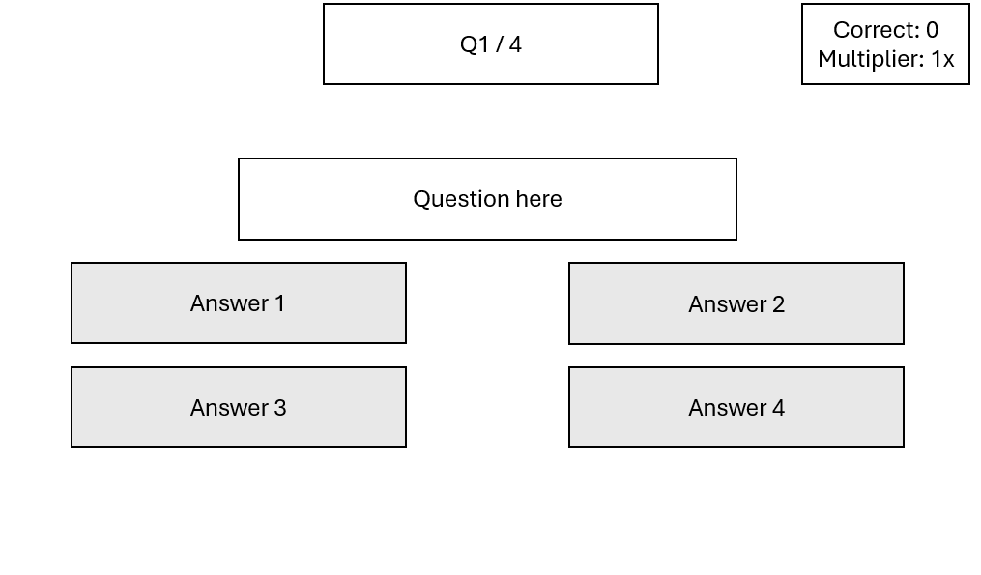
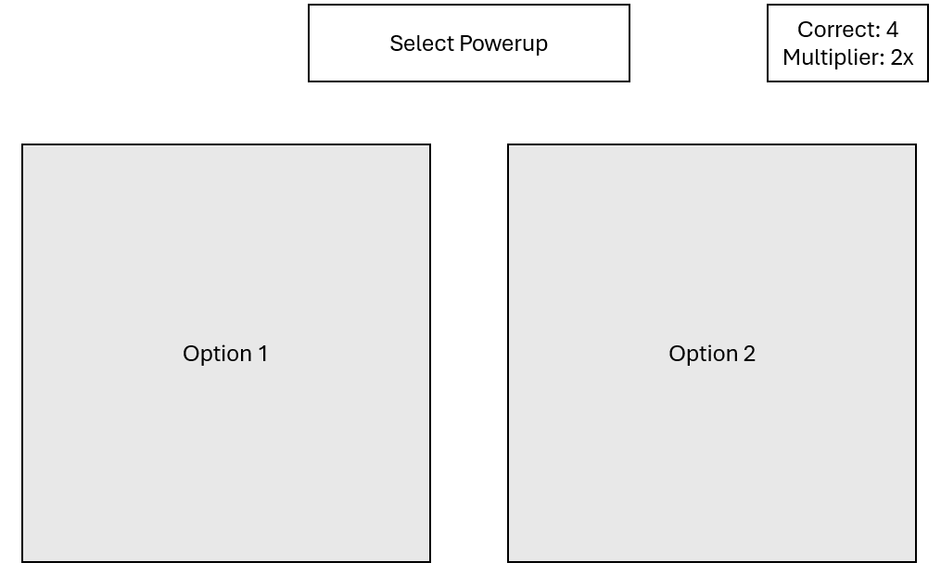
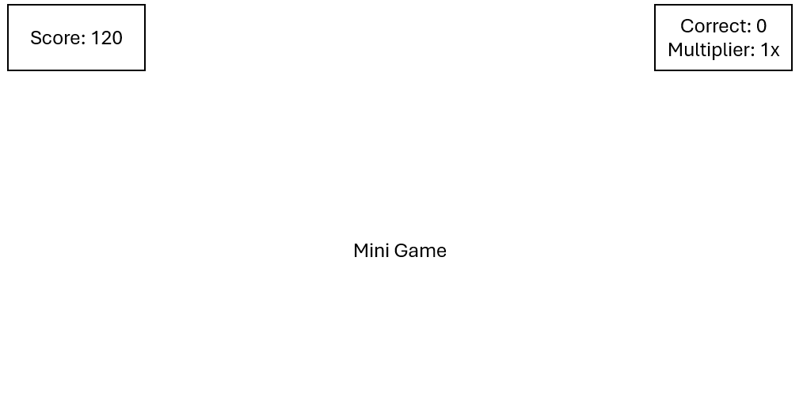
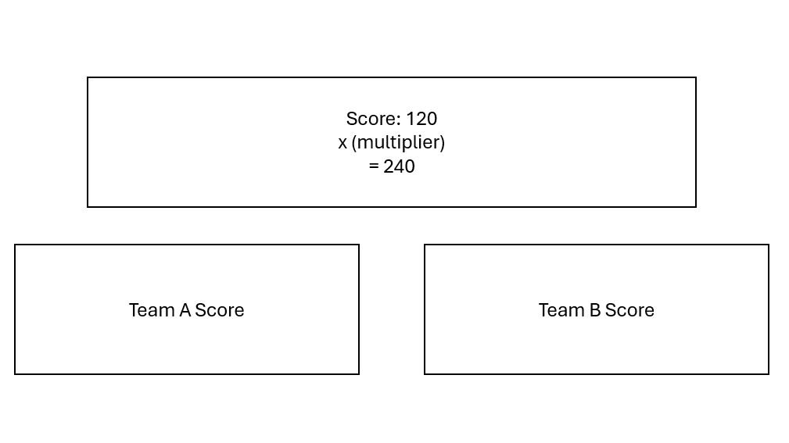
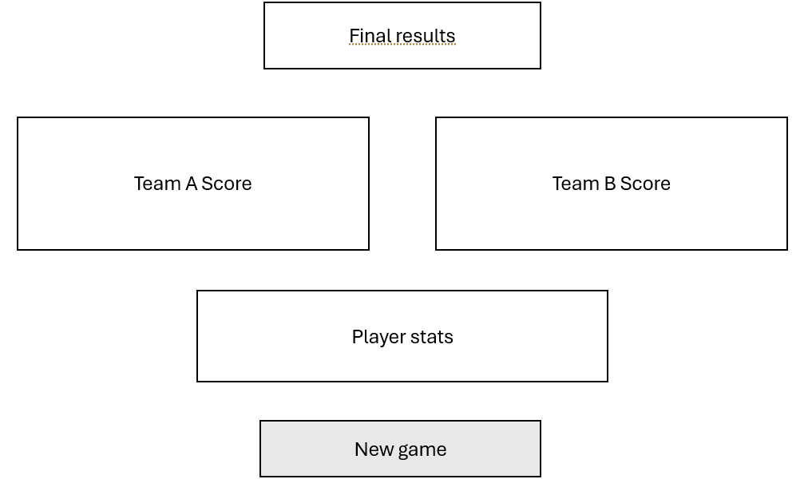
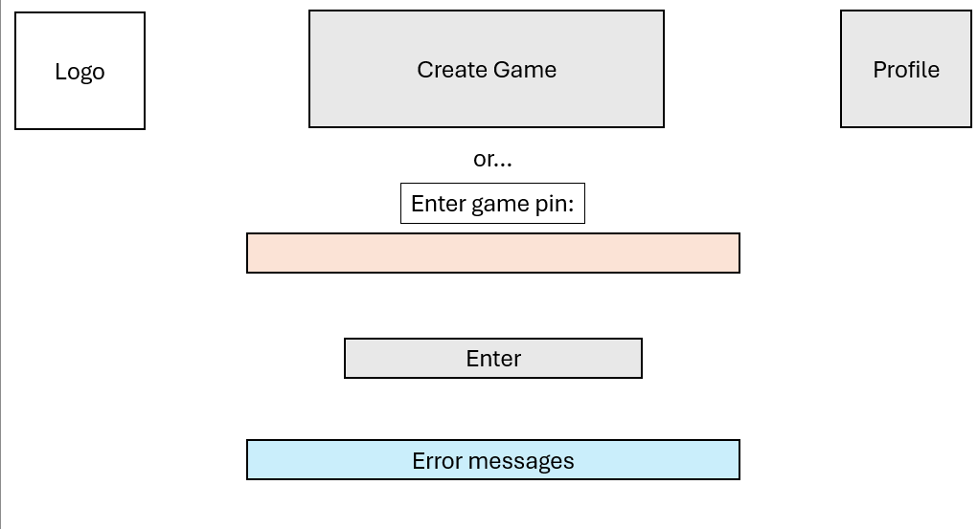
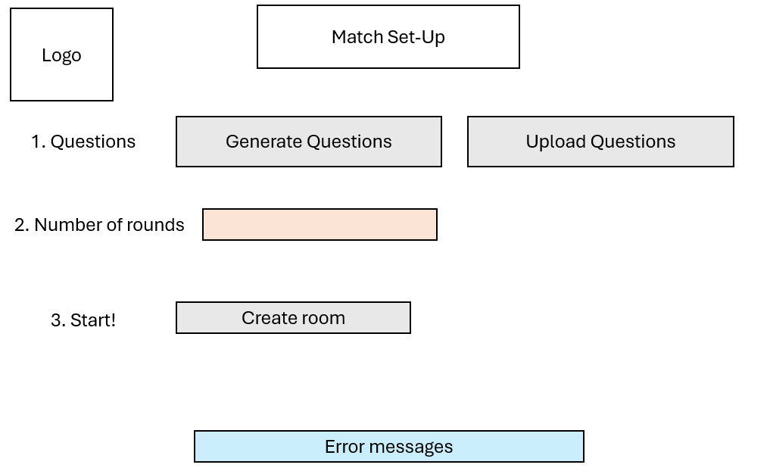
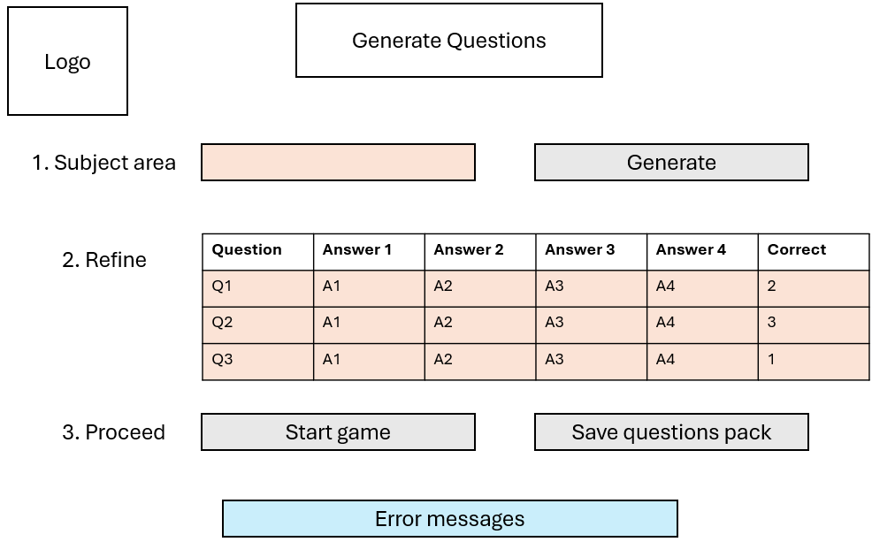
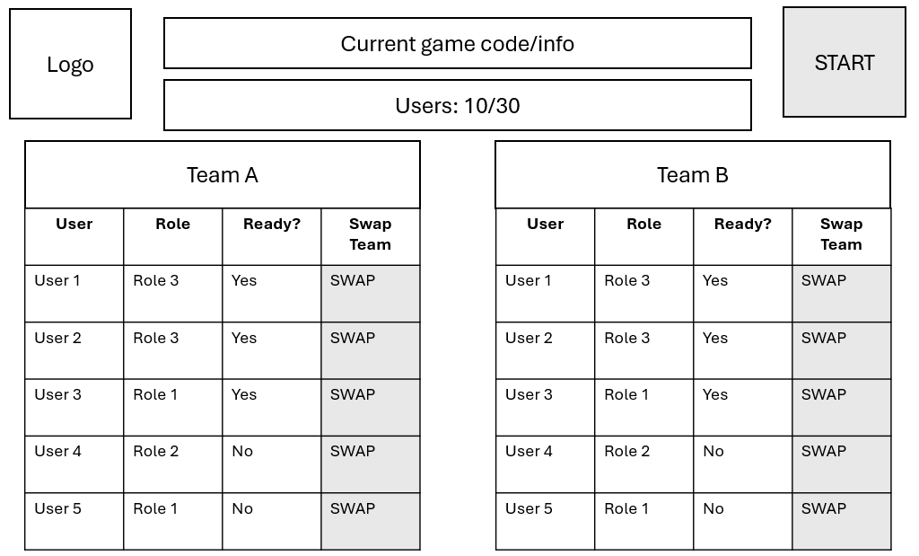
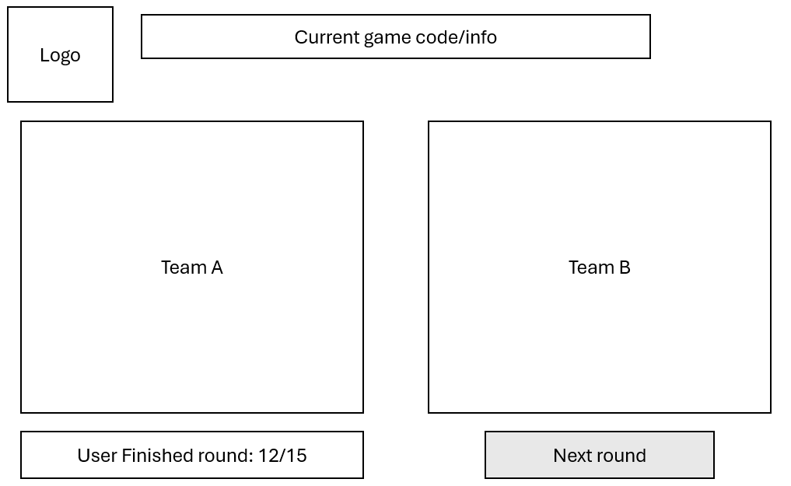
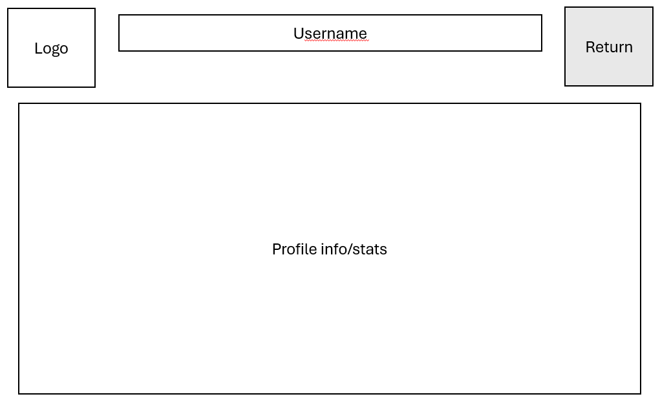
To plan out the website's layout before writing any code, we created a complete set of wireframes spanning 19 screens. These designs clearly separate the user journey and the teachers. The student flow maps out how they log in, enter the room PIN, choose between Team A or Team B, pick a role, and progress through the main game loop of answering questions and playing the mini-games. The teachers outlines the dashboard controls, showing exactly how they create a lobby, generates questions using the AI tool, balances teams by swapping players in the waiting room, and monitors the live scores. To make the development process easier, the wireframes include a color-coded key that defines exactly which elements are clickable buttons, text entry fields, or standard text displays.

Game flow charts (Ed)
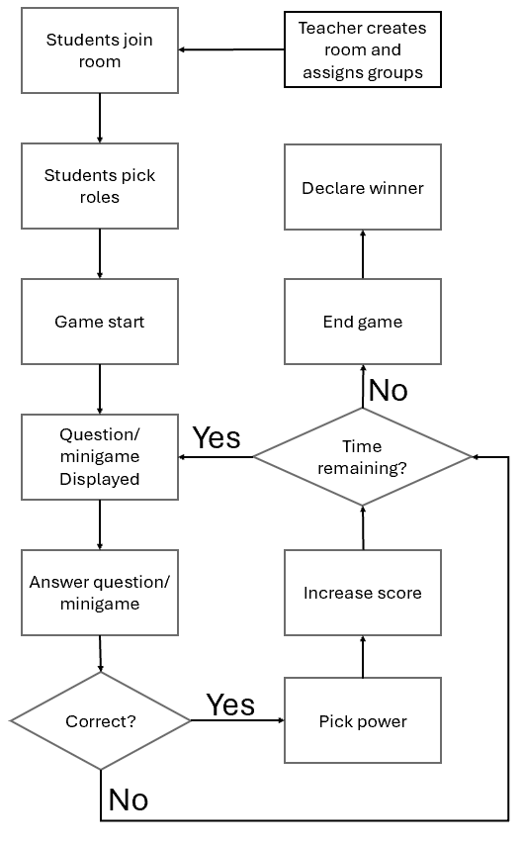
We made this flowchart to map out the exact steps of the game so we knew how to program the loop. It starts with the teacher creating the room and students joining to pick their roles. Once the game starts, a question or minigame shows up for the students to complete. If a student gets it right, they pick a power and get points, but if they get it wrong, they skip that step. After that, the game checks if there is time left. If there is, it loops back to give another question. If time is up, the game ends and declares the winner.
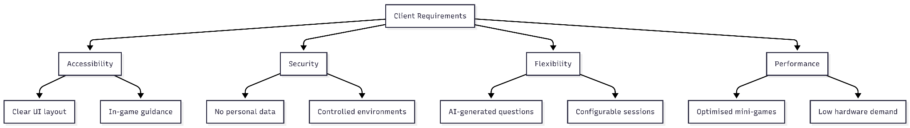
We made this diagram to break down exactly what our client wanted from the project. We needed it to make sure the team stayed focused on the most important goals while we built the website. The chart splits the requirements into four main areas. For accessibility, the platform needs a clear layout and helpful in-game guidance. For security, it must not store personal data and needs to run in a controlled environment. For flexibility, it uses AI to make questions and lets teachers set up their own sessions. Finally, for performance, the mini-games must be optimized so they run smoothly even on slower classroom computers.

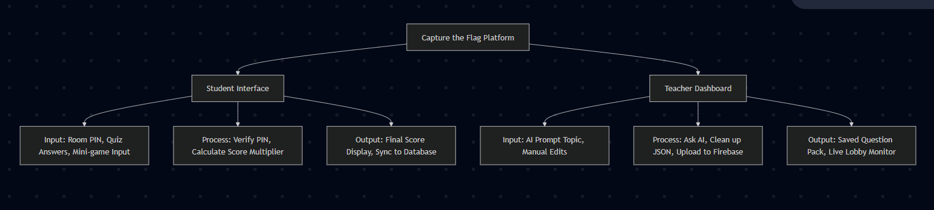
To show exactly how the game runs step-by-step, we made a sequence diagram. This diagram maps out the exact order of events during a game loop. First, it shows the student picking an answer to a question. Then, it shows the website calculating their score multiplier and starting the Unity mini-game. After the player finishes the mini-game, the diagram shows Unity sending the final game score back to the website. Finally, it shows the website combining the scores and sending that total up to the Firebase database, which then updates the teacher's screen in real-time. We included this diagram to prove that the data moves in the correct order without any errors.
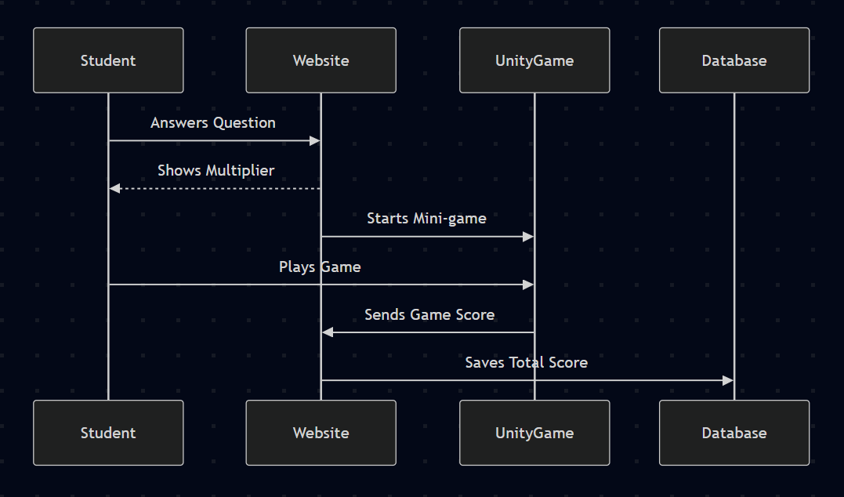
We made this flowchart to show the four basic steps of a match. We needed it so the team and the client could quickly see the order of the game without reading through code. First, players wait in the lobby to join and get assigned to their teams. Next, the gameplay phase starts where students answer the trivia questions. After that, they play the mini-game to earn bonus points. Finally, the match ends at the scoreboard, which shows everyone the final results and the winner.

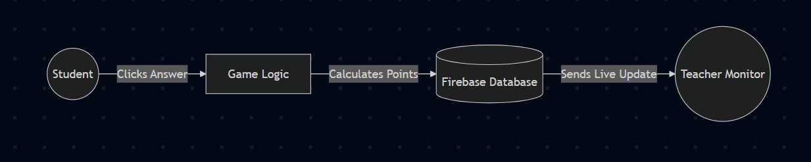
We made a Data Flow Diagram to map exactly how score points move through the system. We needed this to make sure scores didn't get lost when multiple people played at once. It shows the simple path from the moment a student clicks a correct answer, to the website calculating the points, to the database saving it, and finally to the teacher's screen updating live.

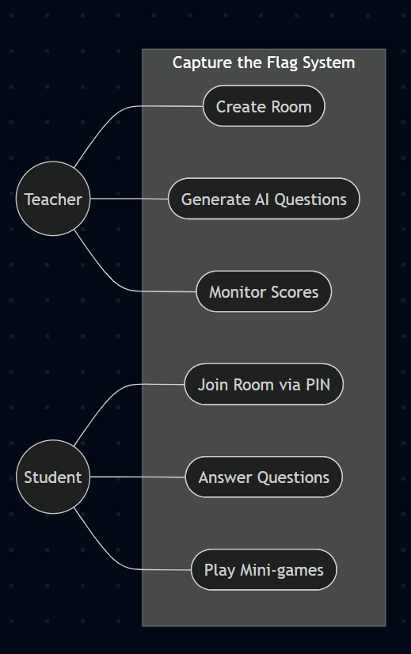
Since the Sequence and State diagrams we already made are technically types of UML diagrams, we chose to create a Use Case diagram to finish this section. We made this diagram to show exactly what a teacher is allowed to do on the website versus what a student is allowed to do. We needed this to prove that our two user roles are strictly separated. It clearly shows that only teachers have the power to create game rooms, monitor scores, and generate AI questions, while students can only join rooms and play the games. Having this visual map made it much easier for us to set up our database security rules to ensure students could never accidentally access the teacher dashboard.

Entity relationship diagram (Ed)
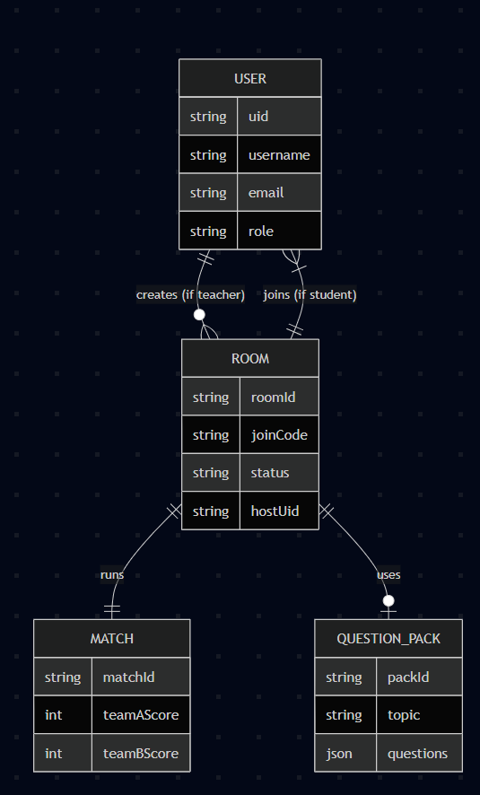
We made an Entity Relationship Diagram to map out exactly how all of our data is stored and connected in the Firebase database. We needed this chart so the whole team understood where important information, like user profiles, room PINs, and team scores were actually being saved. The diagram breaks the database down into four main blocks: Users, Rooms, Matches, and Question Packs. It shows how these blocks interact, such as a teacher creating a room, students joining that room, and the room pulling in a pack of questions for the match. Having this map made it much easier to write the backend code without mixing up where the data was supposed to go.

User Stories: (Marc Jones)
Here is a brief outline of how users can interact with the website and how their needs are met. There are two user types present. One acting as the student and the other teacher.
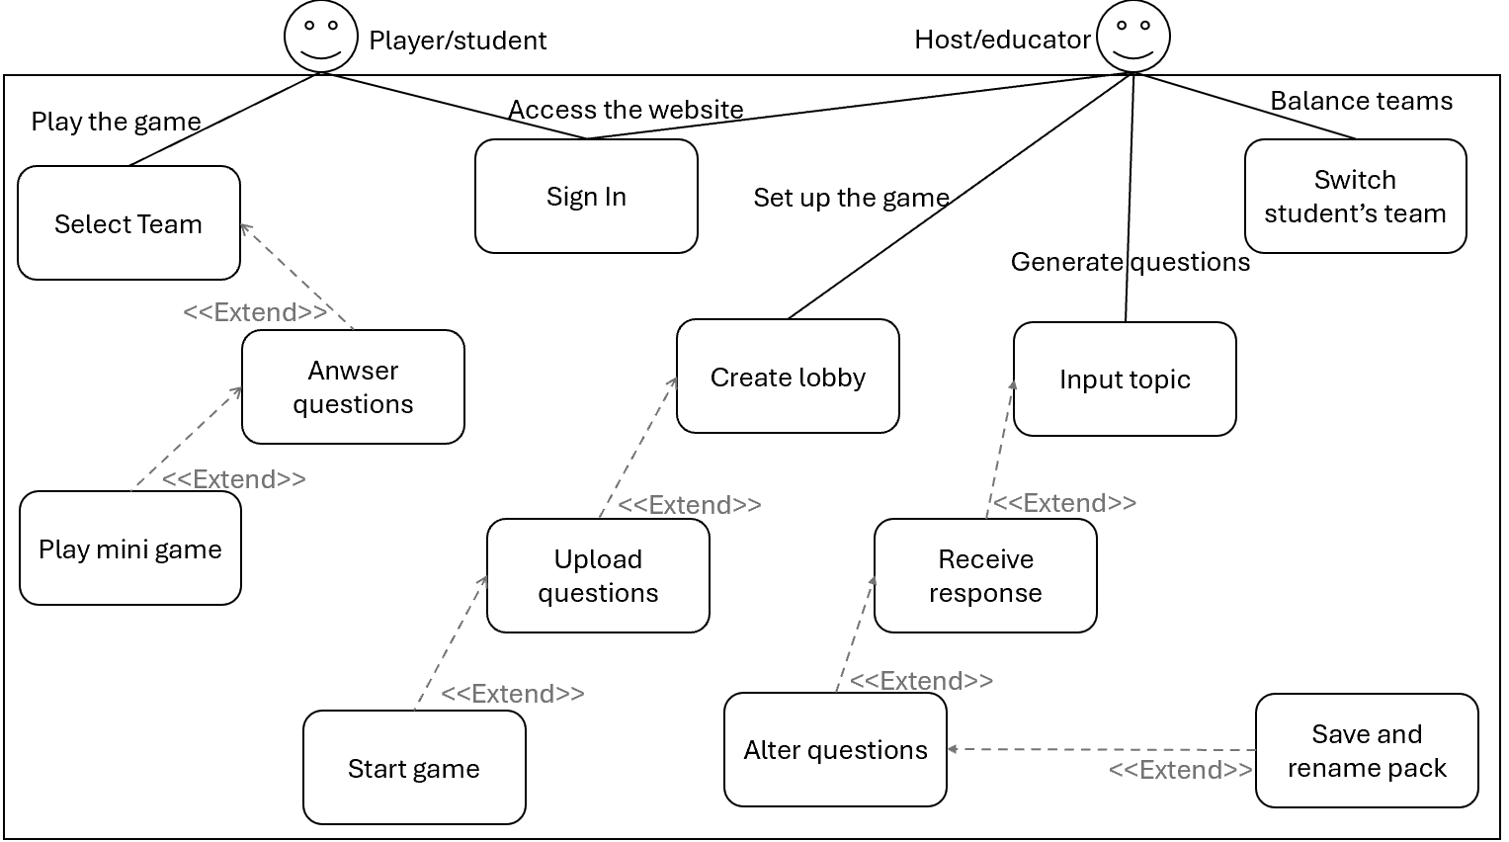
Figure 1 – User stories
It is worth noting that both users cannot access any of their other stories until they have signed in. After this has been completed, they are able to complete their unique tasks. Whilst it may appear that the students only have one option, this is varied through the teachers ability to upload questions for them.

Site Flow: (Marc Jones)
Proceeding follows the flow of the website from the perspective of both students and teachers.
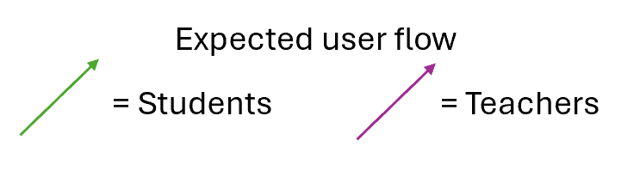
Figure 1 - Key
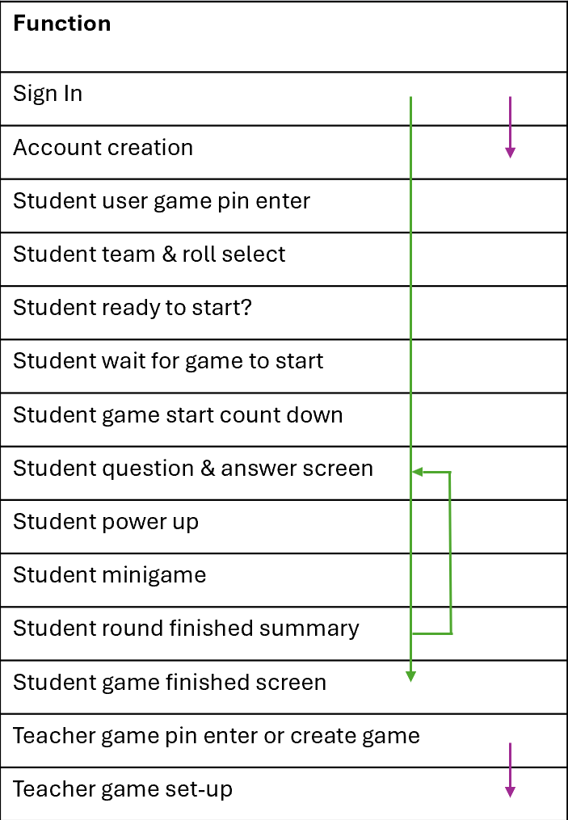
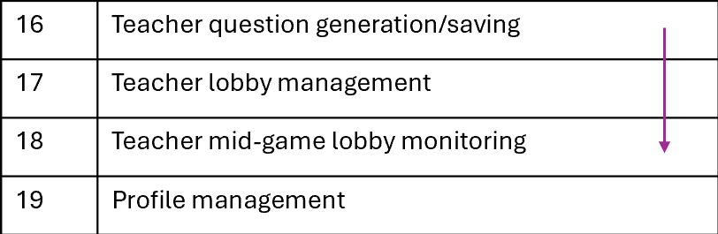
Figure 2 – Site flow chart
This tables shows the initial design flow we had in mind for the website. This was created alongside wireframes to allow for development to start. Without this, there would be confusion over where certain aspects of the website were supposed to be in correlation to others.
There have been slight modifications to the website after this initial plan was made, however. Due to changes in vision, features such as the profile management have been removed entirely.
Another big change that has been made is the separation of the AI question generation from the teachers path of initialising a game for the students. We found this feature to bloat the process of setting up the game. This would have made the website more confusing to those who have not had experience using it. Instead, we chose to move this to a directory of its own so that the two features can exists alongside, not together.

Integration methods

Firebase Authentication: (Aarju Shrestha)
Firebase Authentication provides the identity layer for the platform. Google Sign-In was chosen as the sole authentication method for several reasons: it eliminates the need to build or maintain a password management system; students and teachers within a university environment universally have Google accounts; and it provides a trusted OAuth 2.0 flow with session management handled entirely by the Firebase SDK.

Sign-In Flow
Two sign-in entry points are provided on login.html: one for students and one for teachers, both backed by the same underlying Google OAuth popup flow but diverging after authentication based on the user’s stored role in Firestore.
export async function signInWithGoogle() {
const provider = new GoogleAuthProvider();
const result = await signInWithPopup(auth, provider);
const user = result.user;
try {
await createOrUpdateUser(user);
} catch (err) {
console.warn("Could not save user to Firestore:", err.message);
}

return user;
}
Code1 – Student sign-in function (firebase.js)
The teacher sign-in path additionally calls getUser(uid) after authentication to read the user’s role from the users collection and redirect accordingly. This prevents students from accessing the teacher dashboard even if they navigate to login.html and click the teacher button – unless their Firestore role document records them as a teacher.

User Profile Creation
On first sign-in, createOrUpdateUser() creates a document in the users collection using the user’s Firebase UID as the document ID. On subsequent sign-ins it only updates the lastLoginAt timestamp, preserving any role or profile data already stored. The teacher equivalent, createOrUpdateTeacher(), follows the same pattern but sets role: ‘teacher’ on creation.
export async function createOrUpdateUser(firebaseUser, role = "student") {
const userRef = doc(db, "users", firebaseUser.uid);
const snap = await getDoc(userRef);

if (!snap.exists()) {
// New player - save all their details
await setDoc(userRef, {
uid: firebaseUser.uid,
username: firebaseUser.displayName || firebaseUser.email.split("@")[0],
email: firebaseUser.email,
role: role,
createdAt: serverTimestamp(),
lastLoginAt: serverTimestamp()
});
} else {
// Already exists - just update last login
await updateDoc(userRef, { lastLoginAt: serverTimestamp() });
}
}
Code2 – createOrUpdateUser() profile persistence (firebase.js)

Firebase Firestore Database: (Aarju Shrestha)
Cloud Firestore was selected as the database for its native real-time listener API, which is essential for live score updates during gameplay, and for its seamless integration with Firebase Authentication security rules. Firestore is a document-oriented NoSQL database organised in collections of documents, each of which can contain subcollections.

Initialisation
The database is initialised with the experimentalForceLongPolling option enabled. This was necessary to resolve Firestore connection failures encountered when running the application on localhost during development – the default WebSocket transport was blocked in the testing environment.
const db = initializeFirestore(app, {
experimentalForceLongPolling: true,
useFetchStreams: false
});
Code3 – Firestore initialisation with long polling (firebase.js)

Room and PIN System
The room and PIN system is the mechanism by which students join a specific teacher’s session. When a teacher creates a room, a random 6-digit PIN is generated and stored in the room document’s joinCode field. Students enter this PIN on join.html; the client queries the rooms collection with a where clause to find the matching room.
export async function createRoom(hostUid, settings = {}) {
const joinCode = generatePin();
const roomRef = await addDoc(collection(db, "rooms"), {
hostUid: hostUid,
joinCode: joinCode,
status: "open",
createdAt: serverTimestamp(),
settingsJson: settings
});
console.log(`Room created: ${roomRef.id} | PIN: ${joinCode}`);
return { roomId: roomRef.id, joinCode };
}

export async function getRoomByPin(pin) {
const q = query(collection(db, "rooms"), where("joinCode", "==", pin), limit(1));
const snap = await getDocs(q);
if (snap.empty) return null;
const d = snap.docs[0];
return { roomId: d.id, ...d.data() };
}

function generatePin() {
return Math.floor(100000 + Math.random() * 900000).toString();
}
Code4 – Room creation and PIN lookup (firebase.js)

The PIN is displayed to the teacher on their dashboard and communicated to students out of band (e.g. written on a classroom board). Once a student successfully resolves a PIN to a roomId, the roomId has persisted in localStorage for use across subsequent pages in the session flow

Score Management and Atomic Updates
Team scores are stored in subcollection documents at matches/{matchId}/teams/A and matches/{matchId}/teams/B. Score updates use Firestore’s increment () atomic field transform to prevent lost updates when multiple students submit scores simultaneously.
export async function addTeamScore(matchId, team, points) {
await updateDoc(doc(db, "matches", matchId, "teams", team), {
finalScore: increment(points)
});
}
Code5 – Atomic score increment (firebase.js)
This is a critical safety measure: without increment(), a simple read-modify-write pattern would produce a race condition in which two players finishing a round within milliseconds of each other could overwrite each other’s score contributions. increment() delegates the addition to the Firestore server, which serialises concurrent operations correctly.

Multiplayer: (Aarju Shrestha)
Real-time functionality is achieved through Firestore’s onSnapshot listener API, which delivers document updates to all connected clients within milliseconds of a change without polling. Three key real-time features are implemented.

Live Scoreboard
Both team score documents are monitored independently. When either score changes, the UI is updated immediately:
export function listenTeamScores(matchId, callback) {
let scores = { A: 0, B: 0 };

const unsubA = onSnapshot(
doc(db, "matches", matchId, "teams", "A"),
snap => {
scores.A = snap.exists() ? snap.data().finalScore : 0;
callback({ ...scores });
}
);
const unsubB = onSnapshot(
doc(db, "matches", matchId, "teams", "B"),
snap => {
scores.B = snap.exists() ? snap.data().finalScore : 0;
callback({ ...scores });
}
);
return () => { unsubA(); unsubB(); };
}
Code6 – Real-time score listener (firebase.js)

Waiting Room Trigger
The waiting.html page attaches a listener to the room document. When the teacher changes the room’s status field to ‘in_game’, all connected students receive the update and the countdown animation triggers automatically, redirecting every player to game.html after three seconds.

Live Lobby Members
The listenRoomMembers() function exposes a real-time listener on the memberships subcollection, allowing the teacher dashboard to display a live list of who has joined the lobby and which team they have selected.

AI integration: (Marc Jones)
All code relating to the communication between the website and AI model is contained within ‘Server.js’. This is responsible for establishing the API connection. It mainly features the ‘post’ connection – sending the request.

Hosting
This section of our solution will be completed using ‘Ollama’. This program allows you to run and interact with larger AI models locally. This allows you to either use these models inside the application itself or interact with it via an API. Due to the models being run locally, this means data is kept private
In this case, we are using Ollama to run the model that connects to the backend of our website via its API using Node. The frontend of our website then communicates to this backend to allow for the user input a prompt and have the AI’s response sent back and displayed.
Currently, Ollama is hosted on the HTTP API 127.0.0.1:11434. This should be kept in consideration when connecting to the backend.
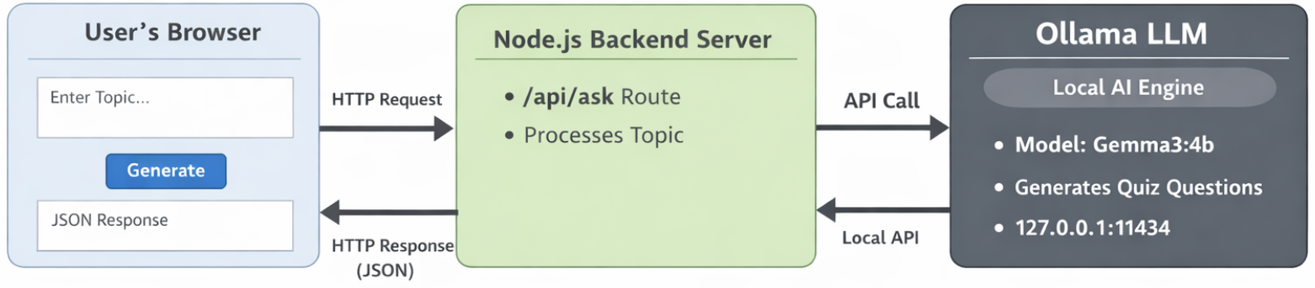
Figure1 – AI website structure

AI model
We are currently using Google’s Gemma3. Gemma is a lightweight set of models built on Gemini technology. This can handle text and image processing – in over 140 native languages. This makes our website more available to other users across the globe (should it be shipped to do so). All model sizes excel in tasks like question answering, summarising and reasoning. It does all this using a very compact structure meaning it can run on a wide range of devices.
After some testing with Gemma, I ultimately decided that Gemma3-4b would be the most suitable. This is the mid-range solution of their models. I attempted to use Gemma3-1b initially but found its responses to be very slightly unsuitable due to a slight bit of inconsistency. These responses were more accurate given the size of the model and could be suitable for running locally on almost any devices, should it need to. I have found Gemma3-4b to be the best of the options – giving acceptable, consistent responses whilst remaining on a small scale and providing very quick responses. Anything bigger than 4b would be insignificant due to the nature of the prompts it is needed for.

Prompts
This model is going to serve one very specific purpose. Generating questions and answers. To make results consistent and user friendly, a generic prompt ‘template’ will be used (within the backend of the website structure). Here, a user (in this case, a teacher) will simply input a topic that they would like to answer questions about and press generate. This will then produce a given number of multiple-choice questions on said topic.
The output of this prompt is given in a JSON format so that these questions can be easily managed by the larger server structure and be saved on the user’s device (locally) to be used at a later date.
Currently, the prompt is as shows:
const basePrompt = `
You are a teacher providing multiple choice questions to students.
Generate 8 questions on the following topic, this should be in a valid JSON format using the following question template:
{
"0": {
"question": "Question text here",
"answers": [
"Answer 1",
"Answer 2",
"Answer 3",
"Answer 4"
],
"correctAns": "The correct answer text here"
},
"1": {
"question": "Question text here",
"answers": [
"Answer 1",
"Answer 2",
"Answer 3",
"Answer 4"
],
"correctAns": "The correct answer text here"
}
// continue with all questions in the same object
}

Rules:
- Do not wrap each question inside a separate array or object.
- Use a single JSON object containing all questions keyed by their IDs ("0" to "7").
- Each question must have four 'answers' and a 'correctAns'.
- Question IDs start at 0 and increment by 1.
- Only output valid JSON; no extra text.

Topic: ${topic}`.trim();
Code1 – Base prompt fed to AI model
This has been refined over time to suit the changing needs/scope of the project. This is almost certainly still not perfect but gave the most suitable responses for its purpose.

JSON formatting
Whilst the response given by the model appears to return with proper formatting initially; minor adjustments must be made to be in a valid JSON format. This is done using the following cleanup method:
const cleaned = fullResponse
.replace(/\\n/g, “\n”)
.replace(/```json/gi, “”)
.replace(/```/g, “”)
.trim();
Code2 – Response cleanup method 1
This is necessary to produce a properly formatted JSON file. It essentially removes the bloating from the output. This is achieved through taking the entire output of the model – in the ‘fullResponse’ variable and putting it through a set of .replace() functions. The first properly formats the line breaks in the question set (from \\n to \n). The seconds removes the marker used at the end of the response (```json ) and replaces it with a null value. The third replicates the second but for the start of the response. Finaly, the .trim() function removes any whitespace before or after the text.
Moreover, I have implemented a few lines of code to remove unwanted text outside of the defined question pack area (contained within the first {}) using the following:
const firstBrace = cleaned.indexOf("{");
const lastBrace = cleaned.lastIndexOf("}");
const jsonString = cleaned.slice(firstBrace, lastBrace + 1);
Code3 – Response cleanup method 2
This is needed due to the nature of how current AI responds with data. Despite the prompt indicating that it should only a valid JSON format, issues surrounding the exact structure remained problematic upon every response I was given, hence the implementation of the cleanups.

File handling
As this website is designed to be used by people of varying backgrounds – it is imperative that it is accessible as possible. We quickly came to the realisation that whilst JSON files may store and handle information efficiently to people with a background in technology, the same can’t be said for others. JSON formatting can look a bit intimidating to those who have never seen them before.
To allow the website to be as user-friendly as possible, I have implemented a system where the questions and answers can be altered in a more comprehensible manner in the form of the JSON editor. The user simply uploads the current file they have, and the editor displays each of these in editable text boxes. The user can change any question they like, along with adding new ones.
The code for this editor is held within the ‘question-generation.js’ file. Here, there are two core functions to make this work: loadItems() and addItem().
The use of the ‘addItem’ function is to create a set of textboxes for each field of each question. These include: the question itself, four answer choices, one correct answer. It does so following a template contained in the HTML file for that page.
function addItem() {
Qcount ++;
const template = document.getElementById("itemTemplate");
const clone = template.content.cloneNode(true);

clone.querySelector("#qNum").id = "qNum" + Qcount;
clone.querySelector("#Q").id = "Q" + Qcount;
clone.querySelector("#aNum").id = "aNum" + Qcount;
clone.querySelector("#A").id = "A" + Qcount;
clone.querySelector("#B").id = "B" + Qcount;
clone.querySelector("#C").id = "C" + Qcount;
clone.querySelector("#D").id = "D" + Qcount;
clone.querySelector("#cNum").id = "cNum" + Qcount;
clone.querySelector("#Correct").id = "Correct" + Qcount;

document.getElementById("container").appendChild(clone);
}
Code 4 – Add item fields
As you can see, each new element that is created is assigned a unique ID value so that they can all be accessed at any point. This is important later down the line when applying the data to each clone. This will be used in two situations (more information on this later).
The implemented ‘loadItems’ function is defined to do exactly as just mentioned.
function loadItems(data) {
QandAs = [];
if (Qcount > 0) {
removeItems();
Qcount = 0;
}
for (const key in data) { //Collect all questions
QandAs.push(data[key]);
}
QandAs.forEach((q, i) => {
console.log(i);
addItem();
let qNumber = i+1
document.getElementById("qNum" + qNumber).textContent = "Question " + qNumber + ":";
document.getElementById("Q" + qNumber).value = q.question;
document.getElementById("aNum" + qNumber).textContent = "Answers:";
document.getElementById("A" + qNumber).value = q.answers[0];
document.getElementById("B" + qNumber).value = q.answers[1];
document.getElementById("C" + qNumber).value = q.answers[2];
document.getElementById("D" + qNumber).value = q.answers[3];
document.getElementById("cNum" + qNumber).textContent = "Correct answer:";
document.getElementById("Correct" + qNumber).value = q.correctAns;
})
}
Code 5 – Load JSON file data
The first few lines are used to convert the JSON format into a one dimensional array (QandAs). The proceeding forEach loop calls the (previously mentioned in code 4) ‘addItem’ function to spawn a template for the question and proceeds to fill in these empty boxes created by assigning the corresponding question data to the respective ID field.
Finally, we have the ‘editItem’ function which operates much like the discussed ‘loadItems’ but in reverse. The primary function of this is for refining the question pack and adding any additional questions that the educator may want to convey to their students.
function editItem() {
const jsonData = {};

for (let i = 1; i < Qcount+1; i++) { //Loop for as many templates are used
let question = document.getElementById("Q" + i).value;
let answer1 = document.getElementById("A" + i).value;
let answer2 = document.getElementById("B" + i).value;
let answer3 = document.getElementById("C" + i).value;
let answer4 = document.getElementById("D" + i).value;
let correctanswer = document.getElementById("Correct" + i).value;
jsonData[i-1] = {
"question": question,
"answers": [answer1, answer2, answer3, answer4],
"correctAns": correctanswer
};
}
const jsonString = JSON.stringify(jsonData, null, 2);

const blob = new Blob([jsonString], {type: 'application/json'});

const link = document.createElement("a");
link.href = URL.createObjectURL(blob);
link.download = "new.json";

link.click();
}
Code 6 – Question pack editing
This operates by iterating through each of the created fields and assigning their contained data to the respective location in the JSON file, under the appropriate headings: ‘question’, ‘answers’, ‘correctAns’. It takes this data and stores it into a the variable ‘jsonString’ and passing this into a Blob object to download this new file.
This editor is primarily designed around the functionality of the AI model providing you with material with the oversight of an academic who is knowledgeable on the subject to correct the AI output should it produce incorrect or misleading information. The person using this editor should not have to have knowledge of the functions of AI nor how this website is designed.
It does however have the ability for the educator to create their own questions from a completely blank slate. This is due to the addition of the ‘Add Question’ button (located next to the ‘Save’ button).
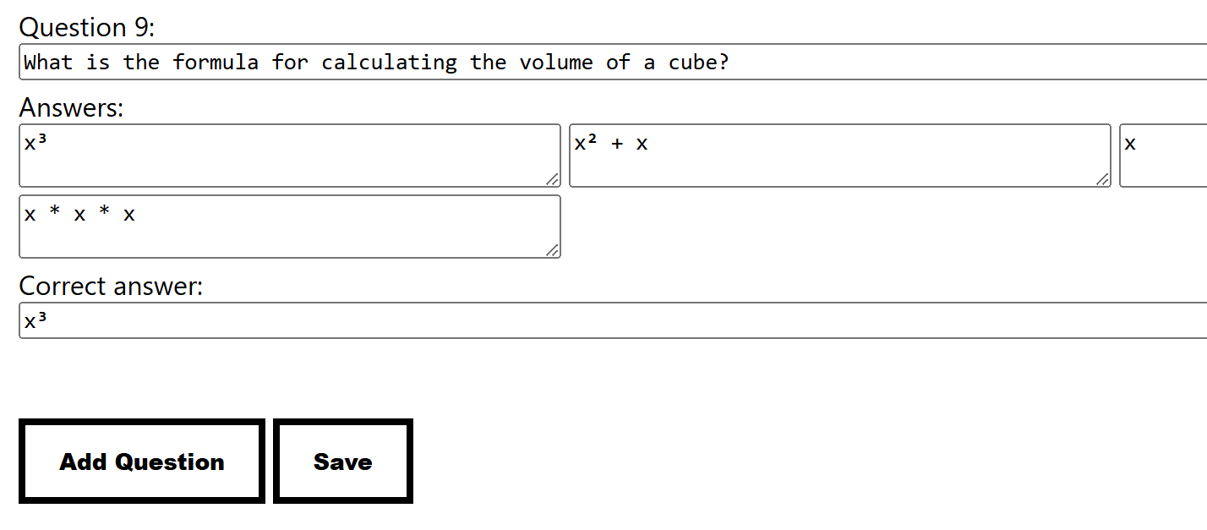
Figure 2 – Buttons showcase
This button calls the ‘addItem’ button (code 4) to display a fully empty question set. This provides extra functionality that proves useful for a range of situations – for example, topics that AI might not be familiar with. In these cases, the educator may find it best suited to create a set of empty question boxes and fill in the data manually to create a tailored question set.

Game Development: (Marc Jones)
Here I will outline the design and implementation of the core function of our website – the game! It was very important that we got this right to satisfy our client.
The majority of the code for this section is contained in the ‘game.js’ file within our project’s directory. However, the ‘game.framework.js’ and ‘game.loader.js’ files are also needed to initialise the game. Thers are stored within the ‘/game’ directory.

Core Game Loop
The website follows the core game loop that we had designed. An example of this is as shown:
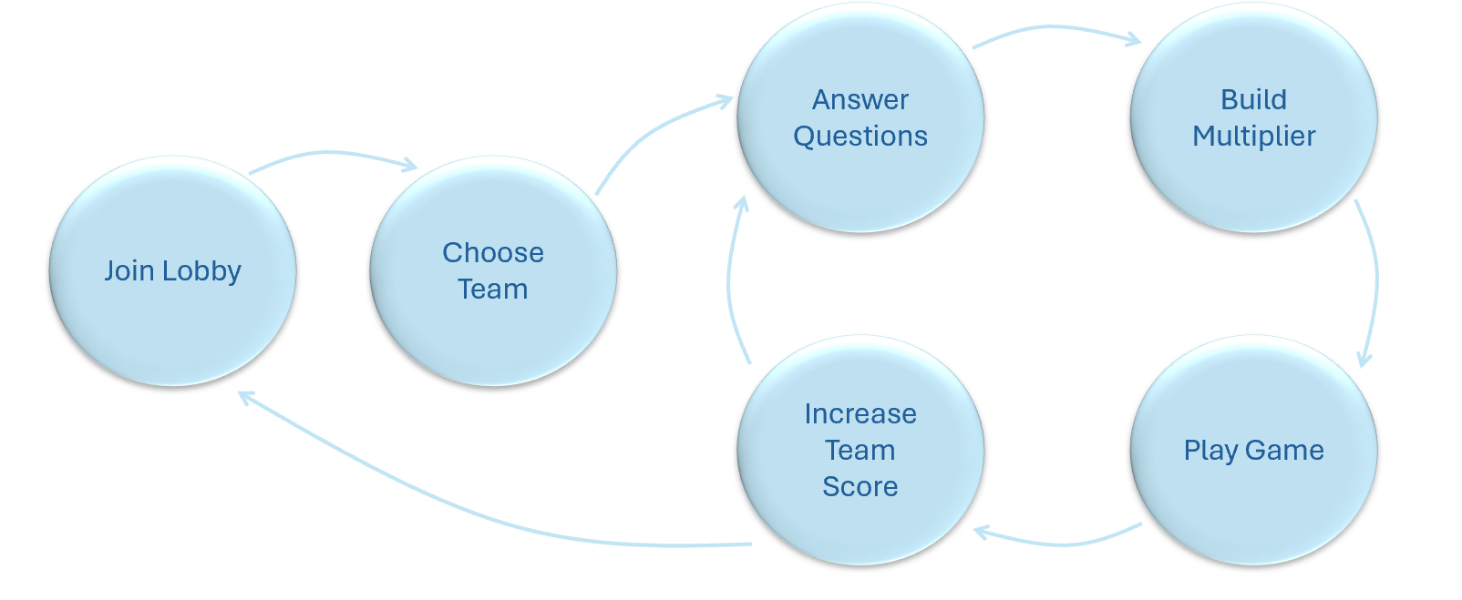
Figure 1 – Game loop
The player starts the loop by joining the lobby (accessed via the room code) and choosing their team – either A or B. Once all players are ready, the game commences.
You start by answering a set of four questions. These are determined by the teacher (more information on this in the ‘AI integration’ section). These questions are displayed in the centre of the player’s screen. It shows the question, followed by the four options the player must choose from. Upon selecting an answer, you find out if you have gotten the answer correct or not. The button either converts to green (correct) or red (incorrect) and displays the appropriate text. If the player gets the question correct, they are rewarded with an additional 0.25x to their current multiplier. This starts at a value of 1x at the start of the question set, achieving a maximum of 2x at the end providing all four questions are answered correctly.
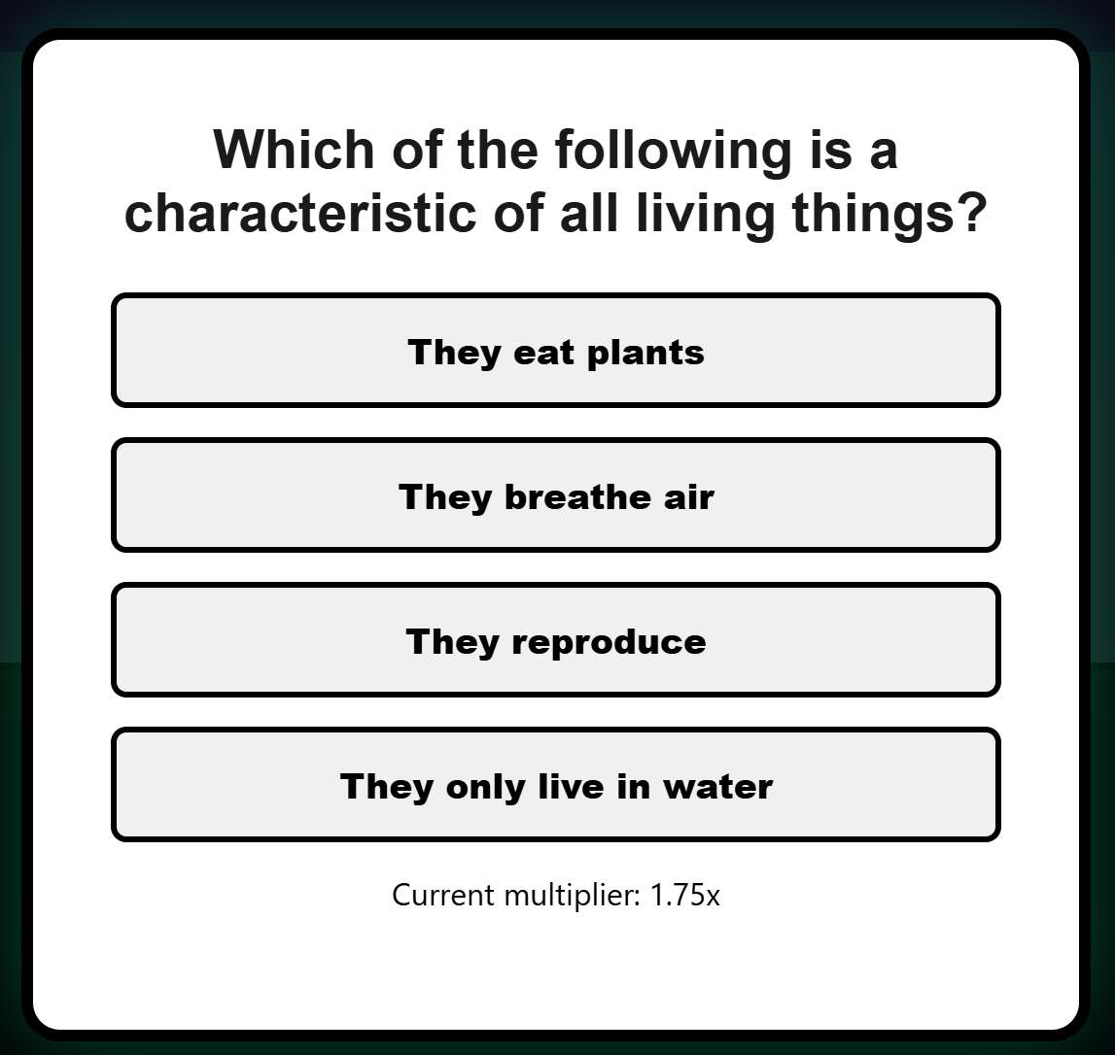
Figure 2 – Question example
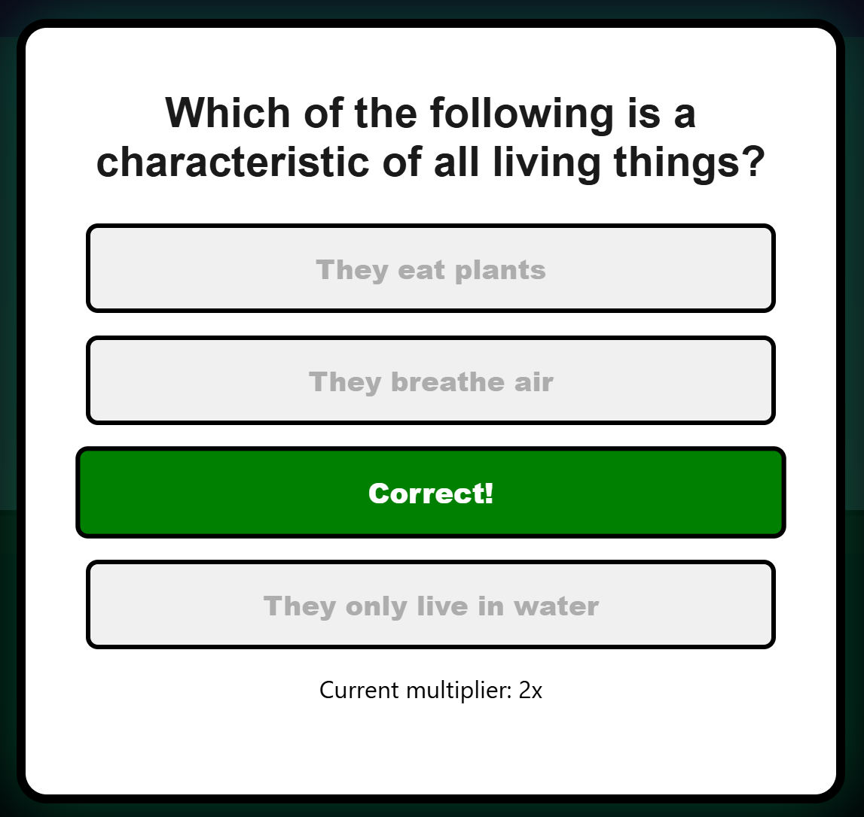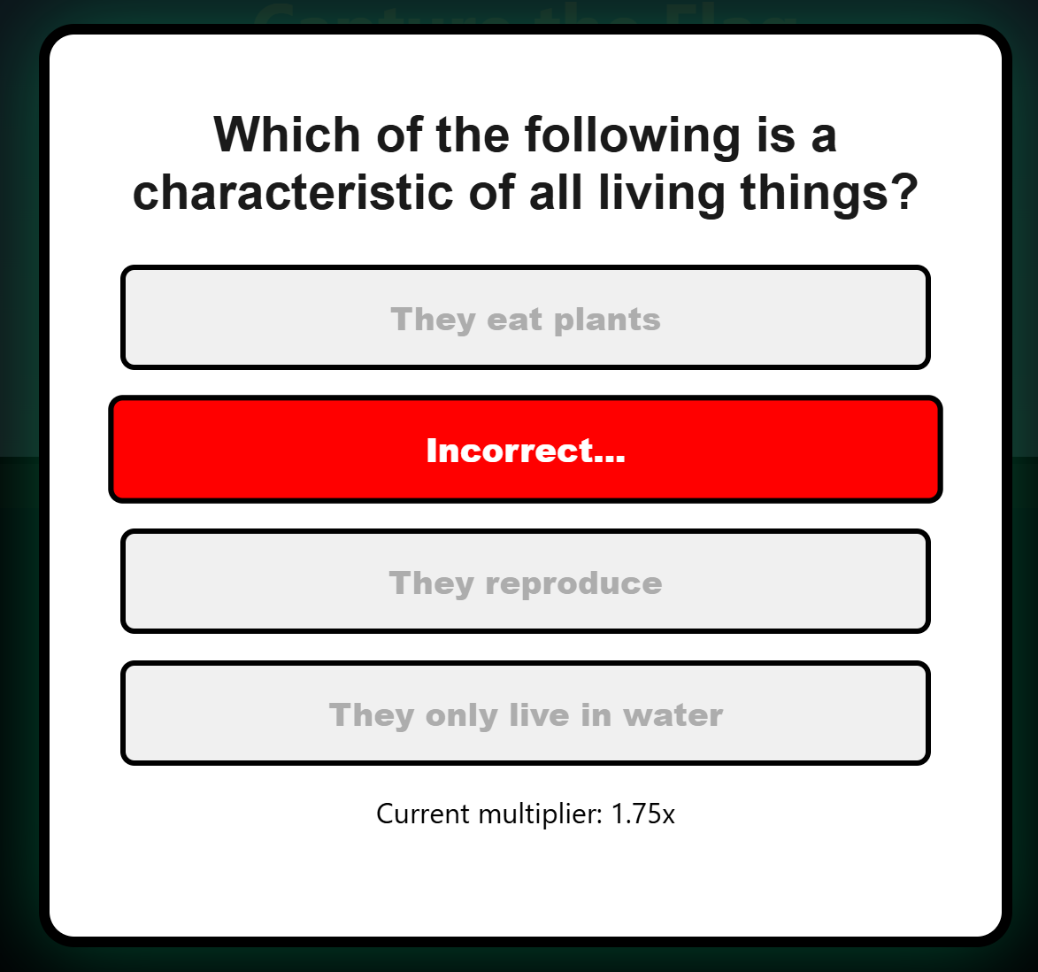
Figure 3 – Question correct Figure 4 – Question incorrect
Following these questions, you are met with a mini game. These are randomly selected from a pool of developed games. These include:
- Stacker: Build a tower as tall as you can. Blocks move horizontally across the screen; you press space to drop them. Any overhang from a dropped block on top of the previous one is removed, creating a smaller and smaller platform to land on until you eventually miss entirely. Points are awarded per dropped block.
- Jumper: Keep running for as long as you can. Obstacles you need to avoid are created from the right and approach you – moving left. To avoid these, simply avoid them by jumping over. These slowly increase in velocity and quantity. Points are awarded per obstacle avoided.
- Flapper: Keep flying for as long as possible. A set of obstacles spawn from the right and approach – moving left (similar to jumper). However, obstacles have a gap located randomly in the middle of the screen and you must fly in this gap to keep going. Points are awarded per obstacle flown between.
- Snake: Keep growing you snake. You achieve this via picking up collectables scattered around the play space. You must avoid running into obstacles and the boundaries of the play space to avoid ending the game. Points are awarded per objective hit (AKA length of the snake)
Should we choose to continue developing this website further following the deadline of this project, we can easily create a larger pool of these games for the player to interact with to keep the game loop feeling fresh and unpredictable.
To gather the players mini game outcome we take the score variable from unity and parse it into the website in the file ‘game.html’ via a custom event shown here:
window.addEventListener( "message", function(event) {
if (event.data && event.data.type === "STACKER_GAME_OVER") {
clearInterval(hackTimer);
const finalScore = event.data.score;
// Dispatch event for game.js to catch and send to Firebase
document.dispatchEvent(new CustomEvent( 'unityGameOver', { detail: { score: finalScore } }));
}
});
Code 1 – Game over custom event
The player’s score is gathered using ‘event.data.score’ and then stored in the ‘finalScore’ variable for future use. This custom event can be used every time the game ends to gather the score.
Then, in the ‘game.js’ file, we then use this ‘unityGameOver’ event listener to find the final score. This is executed in the ‘finalScore’ variable via multiplying the game score (‘e.detail.score’) with the player accumulated multiplier.

document.addEventListener('unityGameOver', async function(e) {
const statusEl = document.getElementById('status');
const finalScore = e.detail.score * multiplier;
const team = localStorage.getItem("team") || "A";
const playerName = localStorage.getItem("playerName") || "Player";
const sessionPin = localStorage.getItem("sessionPin") || "DEFAULT_SESSION";

try {
const sessionRef = doc(db, "sessions", sessionPin);

// Update Score Text
statusEl.textContent = "HACK COMPLETE: " + finalScore + " POINTS!" + " (" + e.detail.score + "x" + multiplier + ")";

// Update Team Total
const updateObj = {};
updateObj[team === "A" ? "teamAScore" : "teamBScore"] = increment(finalScore);
await setDoc(sessionRef, updateObj, { merge: true });

// Update Individual Player Record
const playerRef = doc(db, "sessions", sessionPin, "players", playerName);
await setDoc(playerRef, {
score: increment(finalScore),
team: team
}, { merge: true });

console.log("Scores successfully pushed to Firebase.");

setTimeout(() => {
if (questions.length - currentQ >= 4) { //Start quiz back up if there are 4 or more questions left
startQuiz(questions);
launchUnityGame();
} else { //Finish game loop
statusEl.textContent = "FINISHED";
setTimeout(() => {
window.location.href = 'join.html';
}, 3000);
}
}, 3000);
} catch (error) {
console.error("Firebase update failed:", error);
}
});
Code 2 – Unity game over event
Once the players score has been added to their teams total and posted to firebase (more on this later) and score displays are updated, the program checks to see if it should complete another loop. It does so by checking to see if there are four or more questions left in the question bank. If sufficient question do remain, the ‘startQuiz’ and ‘launchUnityGame’ functions are both called. The reason for launching unity here rather than at the end of the question set is down to player experience and immersion – cutting out the wait time to boot the game by hiding it below the question pop up (leaving the game in a playable state as soon as questions have been answered).

Game Engine
All our mini games have been developed using Unity. We have chosen to implement a game engine to help develop our game section of the website for multiple reasons. Primarily, due to its built-in physics systems.
Currently, three of our games use this physics systems being: stacker, jumper and flapper. These all use the gravity system present in the ‘Rigidbody’ component – in these cases, the ‘Rigidbody 2D’. This automatically handles the vertical velocity displacement per frame.
Alongside this, the collider components are also used here to allow for the player and obstacles to all interact. Allowing for events to happen upon collision like ending the game or providing a ground for the player to rest on.
Whilst these mini games could be replicated through JavaScript using engines such as Phaser – we found unity to provide a very accessible and familiar base to program in whilst remaining lightweight and fully interactable in a HTML structure.
To embed these games, the unity project is exported in a Web GL build. This takes the form of the WebAssembly (.wasm) file located in the /game/build directory. This is then fetched and initialised via the bootstrap ‘.loader.js’ file at runtime. This is executed in the lines (1st and 2nd):
var script = document.createElement("script");
script.src = loaderUrl;
script.onload = () => {
createUnityInstance(canvas, config, (progress) => {
document.querySelector("#unity-progress-bar-full").style.width = 100 * progress + "%";
}).then((unityInstance) => {
document.querySelector("#unity-loading-bar").style.display = "none";
document.querySelector("#unity-fullscreen-button").onclick = () => {
unityInstance.SetFullscreen(1);
};

}).catch((message) => {
alert(message);
});
};
Code 3 – Unity initialising

Worm game mechanics (Ed)
The Cyber Worm game is one of the main challenges players face. When the game loads, players see a dark green title screen that explains the basic controls and tells them to press R to start the system. Once the game begins, the player uses the W A S D keys on their keyboard to guide a digital worm around a grid. The main goal in the standard Secure mode is to navigate the map and collect the yellow folder icons. Every time the worm collects a folder, the worm grows longer and the player earns points for their team. The player has to be careful to avoid crashing into the walls or the fire obstacles scattered around the map, as this will result in a Game Over screen.
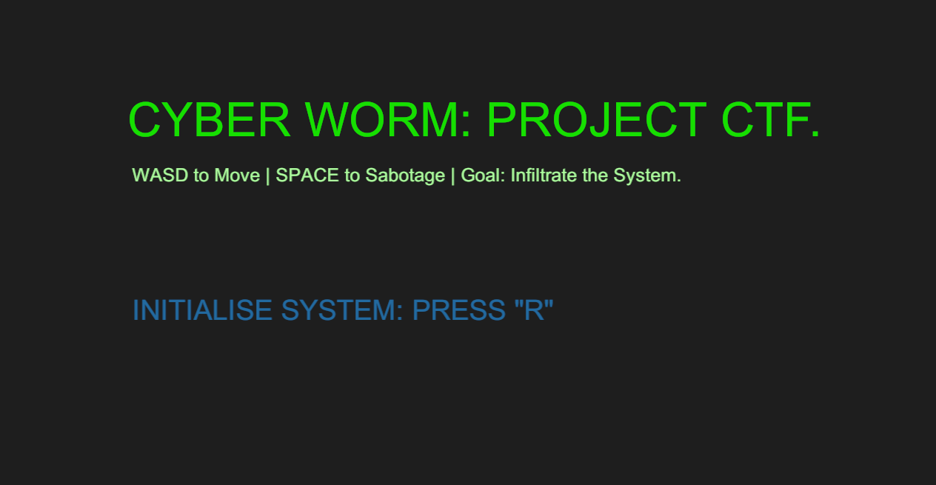
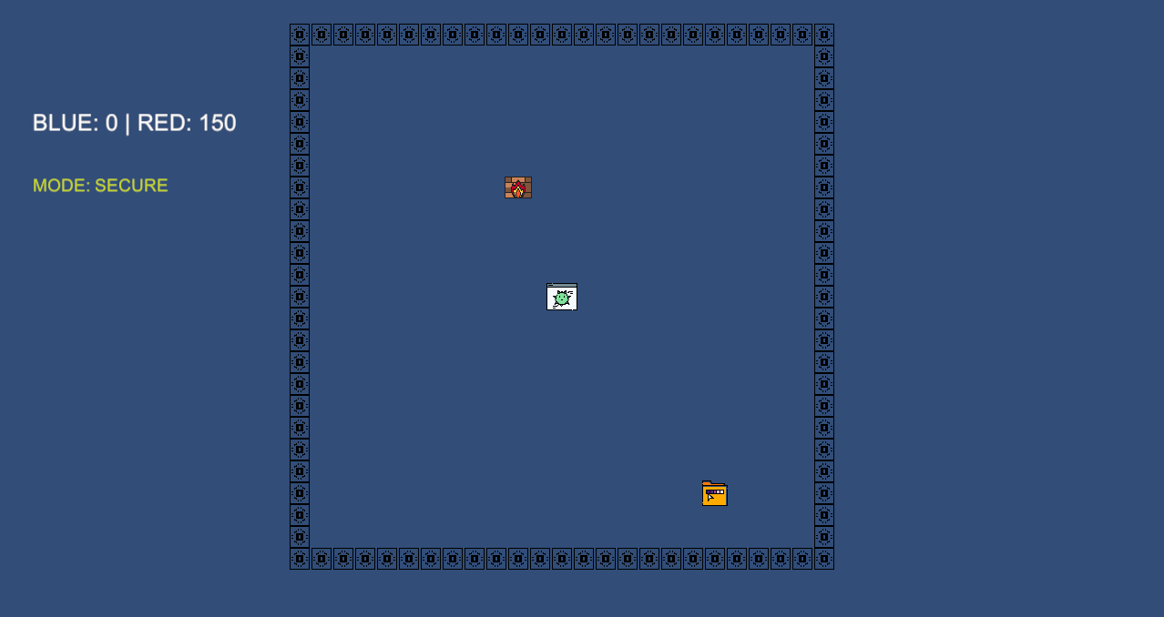


Sabotage Mode
To make the gameplay more strategic, we added a special feature called Sabotage mode. At any point during the game, the player can press the spacebar to switch modes. When they do this, the worm instantly turns bright red, and the screen updates to show they are in Sabotage mode. In this red state, the rules completely change. Instead of earning points for their own team, collecting the folders actually takes points away from the enemy team. This gives players a very interesting choice. They have to decide if it is better to build their own score up or focus on ruining the score of the other team.
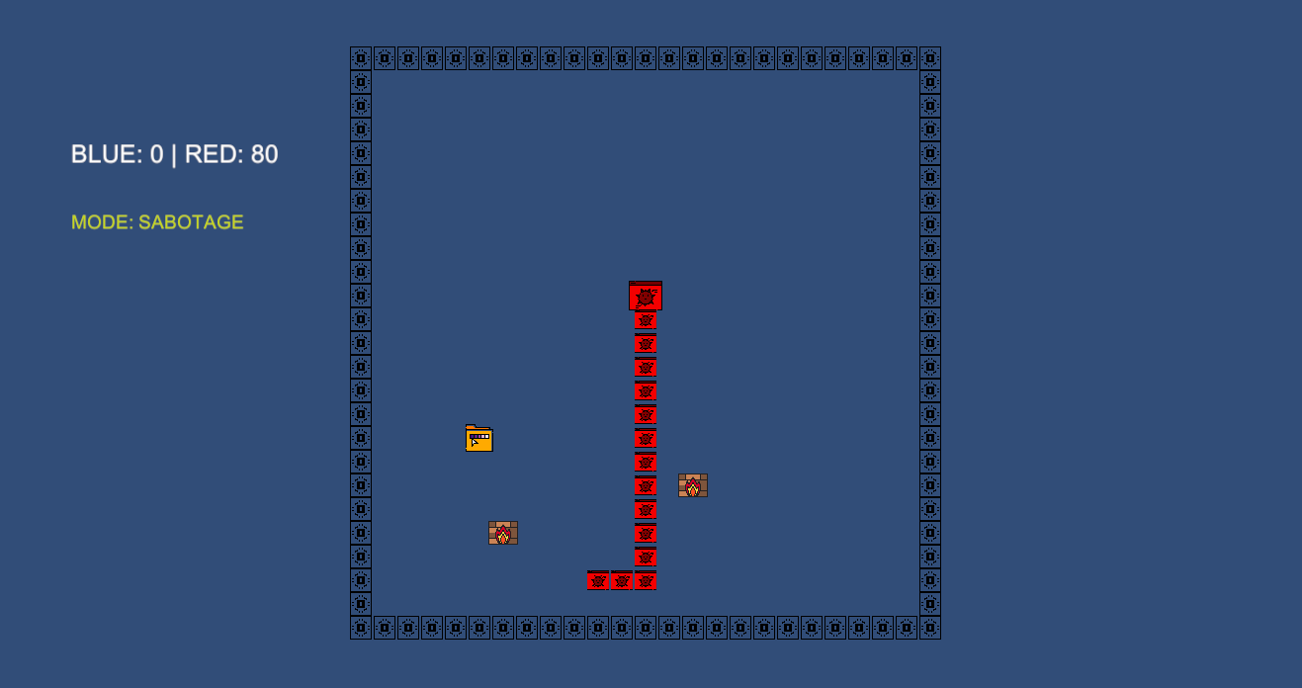

Playtesting and Feedback
To make sure the game was actually fun and worked exactly as intended, I conducted some testing outside of the university environment. During a work placement at Four Millbank in London, I asked a few different groups of people to try the game out. I had some senior ship brokers play it, which was incredibly helpful to see if the controls made sense to older professionals who do not normally play computer games. I also had a young trainee and another work experience student test the game to get honest feedback from a younger crowd. Everyone gave it very positive reviews and found the Sabotage feature highly engaging. Following this success, I posted a short summary of the working game on LinkedIn. Both our client and our module leader interacted with the post and liked it, which gave us great confidence that the project was heading in the right direction.
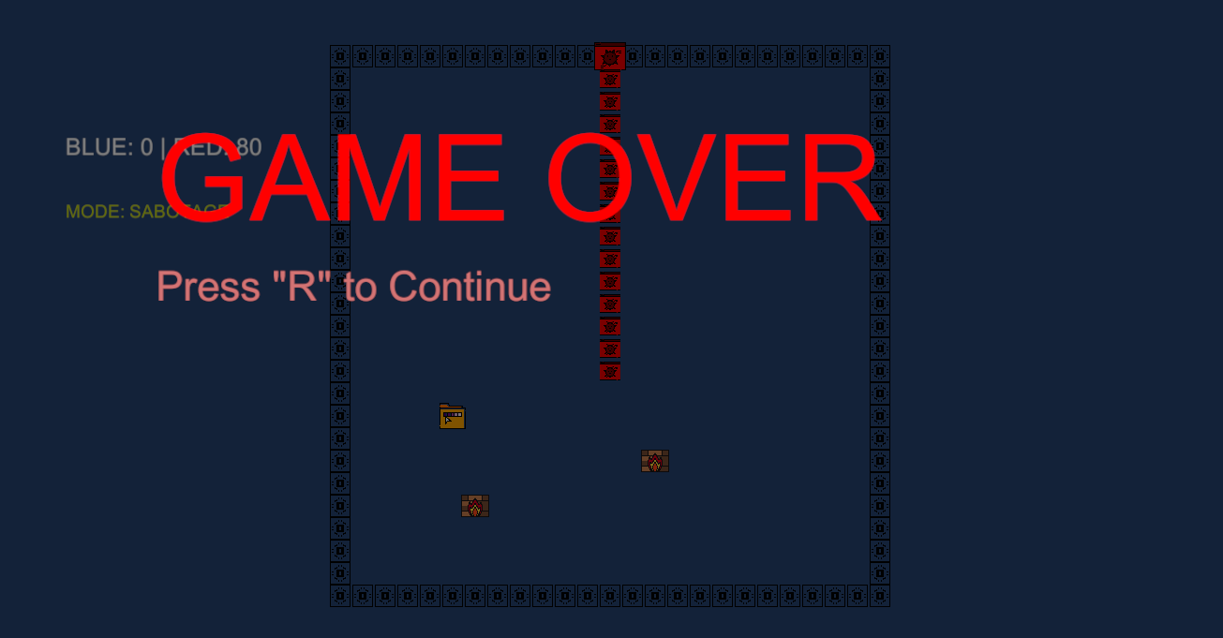
The game will then lead to the next set of questions or end depending on what stage the users are while playing.

Stacker game mechanics (Ed)
The Stacker game is another challenge we built to keep the loop fun and engaging. The rules for this one are very simple. When the game loads, there is a starting screen waiting for the player to begin. Once the game starts, a block moves from side to side across the top of the screen. The player just has to press the spacebar to drop the block straight down. The goal is to stack the blocks as high as possible without them falling over. To make it visually interesting, the blocks come in lots of different colours. If the player times it wrong and misses the stack, the block falls off the screen and the game ends. I am including three pictures of this process in the report showing the game right before it starts, a block moving across the screen, and what happens when a player misses.
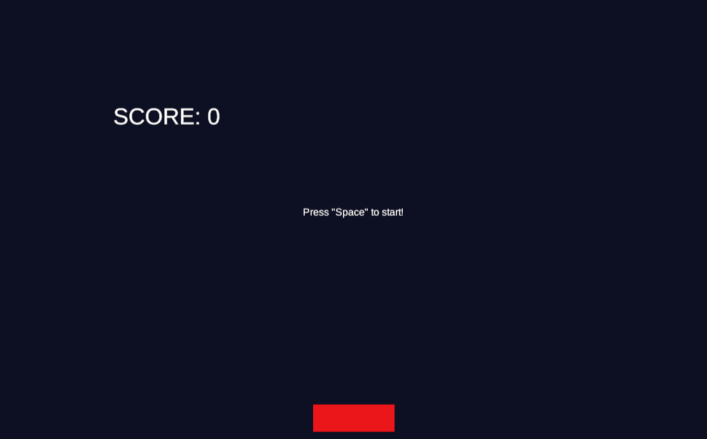

Game Design and Simplicity
While the cyber worm game has complex features like the sabotage mode, the stacker game was designed to be completely straightforward. It is based on classic arcade games that most people have already played at some point in their lives. We chose this simple design on purpose so that players do not have to spend time learning new rules. Because it is so familiar and easy to pick up, it acts as the perfect quick break between answering the trivia questions. It keeps the energy high without distracting from the main educational goal of the website.
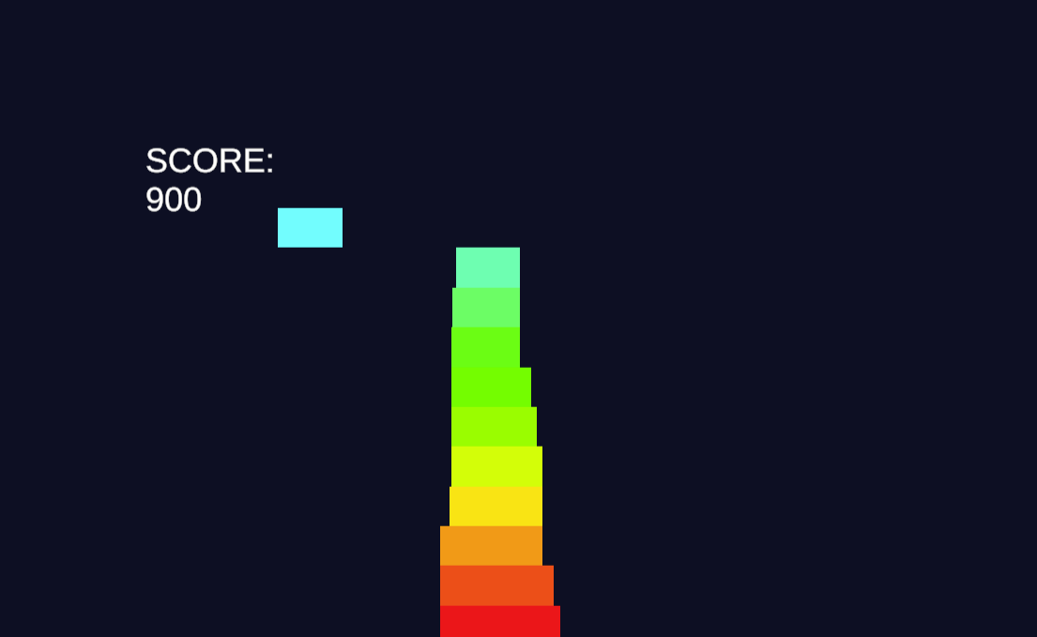
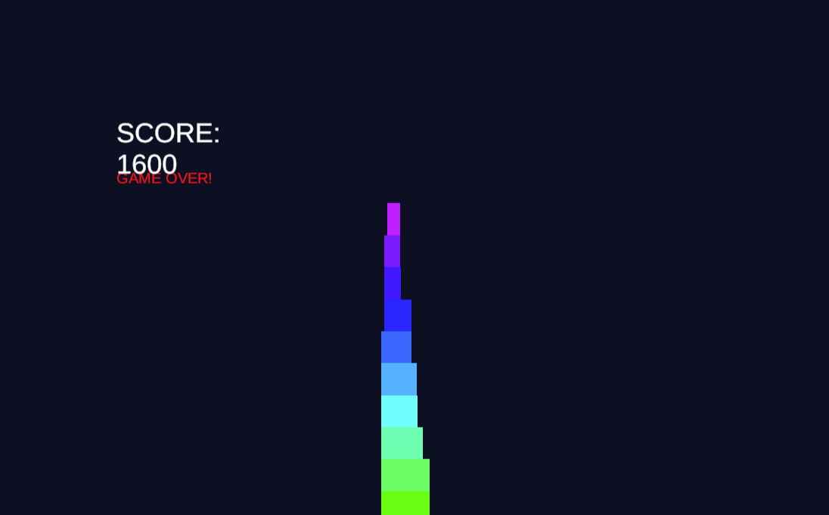

Play Testing and Feedback
To make sure this simple gameplay loop actually worked well in practice, I asked a large group of university students to play test the system. I wanted a good mix of people with different skill levels, so I got students from architecture, civil engineering, computer science, business, and biomedicine to try it out. I just asked them verbally if they were happy to test the game and give me their honest thoughts, which kept things very casual without needing to hand out formal consent paperwork. Everyone gave the game really good reviews. They all agreed that having a familiar and simple game to play made the whole experience much more enjoyable and proved that the system works perfectly for any classroom environment.

Frontend Design and Implementation:

Design Language: (Aarju Shrestha)
The visual design of the platform is built around a retro cyber-security aesthetic: a dark background (#130f24), electric blue accent highlights (#00e5ff for correct answers and active states), and a deep violet primary colour (#6c2bd9) for interactive elements, borders, and the top navigation bar. This palette was chosen to resonate with students studying cyber security, evoking the visual language of hacking interfaces and terminal environments familiar from the discipline.
Typography uses the system-ui font stack to ensure maximum compatibility without requiring font downloads. Headings use bold weights at large sizes to create clear visual hierarchy. Interactive buttons feature thick solid borders and hover states with glow box-shadows to provide satisfying feedback on interaction.
Decorative SVG assets: a circuit-board background pattern, floating flag icons, and a hacker-fox mascot character are layered as absolutely positioned background elements across the authentication and lobby pages. These are set to pointer-events: none and use opacity to remain visually present without interfering with interactive content.

Page-Level Structure: (Aarju Shrestha)
Every page follows a consistent structural template: a fixed .topbar containing the site logo tabs and decorative window control buttons, followed by a screen content area. The topbar uses #6c2bd9 as its background, providing persistent brand presence across all pages. The screen area applies a sky-to-white gradient on lobby/auth pages and a dark space background on game.html.
Content cards (.welcomeCard) are centred at max-width 640px with a semi-transparent background and a thick black border, placed above the decorative background layers using z-index management. This ensures legibility against the textured background while maintaining the visual depth of the layered design.

Responsive Design: (Aarju Shrestha)
Media queries at 1000px and 700px breakpoints adjust the size and position of decorative elements to prevent them from obscuring content on narrower viewports. The hacker-fox mascot is hidden entirely on mobile (max-width 700px) as it is purely decorative and occupies a significant proportion of small screens. The team selection grid on team-select.html switches from a horizontal flex row to a vertical column at 700px.

Key UI Components: (Aarju Shrestha)

Option Buttons (Quiz Answers)
Answer buttons on the quiz modal use a custom .option-btn class with a dark purple background, electric blue border, and a hover state that fills the background with the border colour and adds a glow effect. On answer, buttons are immediately disabled and their text replaced with ‘CORRECT! +100 PTS’ or ‘INCORRECT’, with corresponding colour changes via .disabled-correct and .disabled-incorrect modifier classes.

Quiz Timer Bar
A progress bar beneath the question text visually represents the 10-second answer window. It is implemented as a CSS width transition applied to a div, shrinking from 100% to 0% over 10 seconds via a linear timing function. The colour transitions from electric blue to red in the final three seconds as a visual urgency cue, achieved by modifying the backgroundColor property in the interval callback.

Waiting Room Countdown
The countdown animation uses CSS transform and opacity transitions to create a scale-in effect for each number. The number element is given the .visible class to trigger the transition, removed and re-added with a 400ms gap to create a pulsing appearance for each digit of the 3-2-1 countdown.

Team Selection Cards
On team-select.html, Team A and Team B each have a card styled with green and red gradients respectively. Role buttons within each card use a .role-btn class; clicking any button adds a .selected class and sets the data-team and data-role values used by the confirmation step. Sound effects (assets/click.wav and assets/confirm.wav) play on selection and confirmation via the Web Audio API.

Background Visual Assets (Nicholai Baes)
A consistent cyber-themed visual identity is maintained across all interface pages through the use of layered SVG background assets. These include background_circuit_blobs.svg as a low-opacity circuit-board texture, login_decor_sprites.svg as abstract floating geometric sprites, floating_flags.svg as thematic Capture the Flag branding and hacker-fox mascot create a consistent visual identity without distracting from the main controls. These assets are positioned using absolute CSS placement with controlled z-index stacking so that they remain non-interactive (pointer-events: none) while providing depth behind the functional UI. Opacity levels are deliberately reduced to avoid visual obstruction of gameplay controls while preserving the cyber-security aesthetic and strengthening continuity between pages.
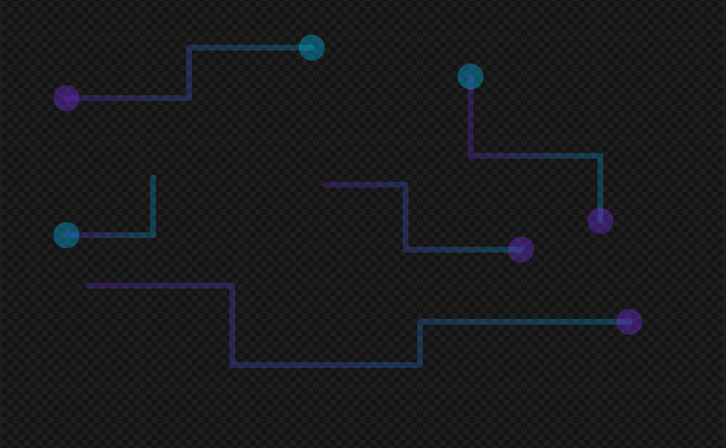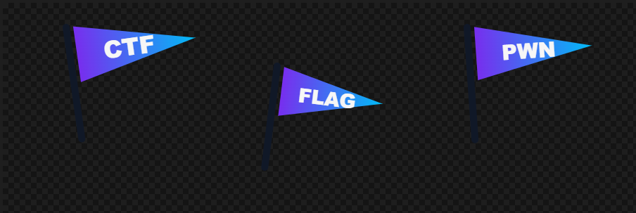
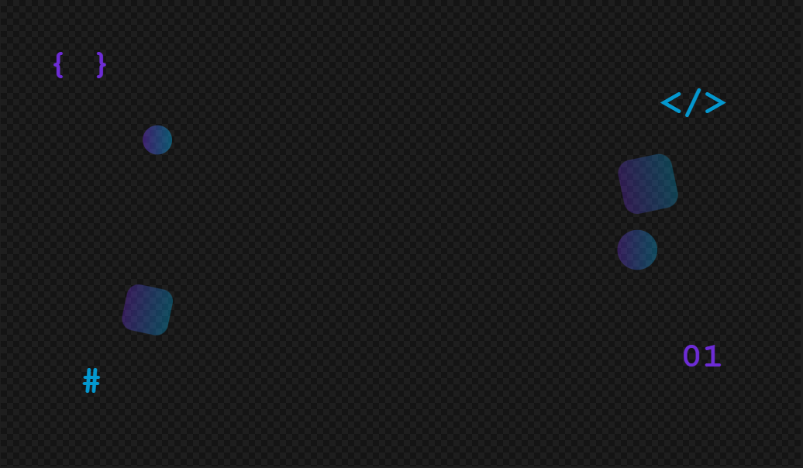

Audio Assets (Nicholai Baes)
The project incorporates a small set of audio assets to enhance user interaction and overall engagement. Short, sounded effects such as click.wav, hover.wav, and confirm.wav are used throughout the interface to provide Immediate feedback when user interact with buttons. These assets were made with AI. The sounds help enforce actions, making the interface feel more responsive and intuitive.
In addition to interface feedback, Mini-Game Shuffle.mp3 using Suno to generate AI music. It’s used to engage the classroom and adds a sense of progression between quiz rounds and gameplay. Helping to pace and player engagement during the session

Accessibility Features (Nicholai Baes)
A reusable accessibility settings widget was implemented globally across the web prototype to improve usability for a wider range of users. This widget contains a dark mode toggle, a dynamic text scaling system, and a high-contrast mode. Dark mode is handled through a data-theme="dark" attribute applied to the document root, which swaps the CSS custom property colour palette to darker backgrounds and lighter text values.


Text scaling is achieved through a --font-scale CSS variable, allowing headings, buttons, labels and body text to resize proportionally when the user selects A- or A+.
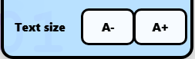

High contrast mode applies an additional data-contrast="high" attribute that replaces translucent interface cards and soft gradients with solid black/white visual blocks and stronger border outlines. All settings are controlled through JavaScript in theme.js and persisted using localStorage, ensuring the user’s accessibility preferences remain active when navigating between pages.


Quality Assurance(Nicholai Baes)
Quality assurance was carried out throughout development to ensure the platform was function, usable, reliable and suitable for classroom use. Because the project combines authentication, real-time database updates, AI generated content and unity WebGL mini-games, Testing focused on both individual components and the complete end to end user journey.
Unity Testing and component testing were used during development to verify core functions independently. Firebase related functions such as room creation, PIN lookup, user profile creation and score updates were tested separately before being integrated into the wider system. Attention was given to the score update login, as multiple students may submit scores at similar times. Firestore’s atomic increment() function was used to reduce the risk of race conditions and ensure team scores remain accurate during concurrent updates.
The authentication flow was tested using both student and teacher sign in paths. This confirmed that google authentication worked correctly, user profiles were created on first login and users were redirected to the correct area of the platform based on their role. Additional testing was performed by attempting to access pages from a student account, helping verify that role separation was working as intended.
User acceptance testing was also concluded informally during demonstrations and walkthroughs. Feedback from Dr Rory Hopcraft was used to access whether the system met the original educational brief. This led to several improvements, including separating AI question generation from game setup, improving the clarity of the PIN entry flow and adding a visible PIN reminder during gameplay.
Question generation was tested using a range of topics to check whether the AI produced usable multiple choice questions in the expected JSON format. Since AI output can be inconsistent the system includes a JSON cleanup process and an editable review stage, this ensures that a teacher can correct, remove, or rewrite generated questions before they are used in a live session.
Cross browser testing was carried out on Chrome, Firefox, and edge to confirm that the interface, firebases connection and unity WebGL game loading behaved consistently. Responsive design testing was also performed on different screen sizes to ensure the platform remained usable on desktop and tablet sized devices
Overall, quality assurance was handled as an ongoing process rather than a final stage activity. Issues discovered during testing were added back into the development workflow, prioritised and resolved during later sprints cycles.

Limitations and Future work (Nicholai Baes)
Although the final system meets the core project requirements, multiple limitations remain. The AI questions generation tool currently depends on a locally running Ollama server, meaning it is not fully cloud hosted and requires setup on the teachers machine, The Unity mini games are embedded successfully, but the current pool of games are limited, so repeated classroom use would benefit from additional mini games. The system also relies on browser LocalStorage to persis temporary session state between pages, while defensive checks are implemented, a more robust version could use server-side session tracking.
Future work could include a teacher analysis dashboard showing individual student performance, question accuracy rates and a team contribution breakdown. Automated testing could also be expanded, particularly for firebase security rules, role based access control and multiplayer score updated under simultaneous submission.
Also considering adding a small security considerations section after firebase/firestone. That would fit a computer science project well and show awareness of authentication, role check and AI generated content validation.

Conclusion(Nicholai Baes)
The project successfully delivered a web-based multiplayer computer science learning platform that combines quiz based learning with interactive unity minigames, the final system allows teachers to create game rooms, generate and review AI assisted question packs, launch classroom sessions and monitor live scores. Students can authenticate, join using a PIN, select team and role, answer questions, play minigames and contribute to their teams score in real time.
The main project achievements include the integration of firebase authentication, cloud firestore, real time multiplayer score synchronisation, AI question through Ollama and Gemma3-4b and unity WebGL mini-games embedded into the browser. Together these components from a complete educational game loop that meets the clients original aim of making computer science teaching more engaging and interactive.
As a team we gained significant experience in full stack web development, database design, real time systems, game integration, AI tool, version control, and Agile project management. We also learned the importance of client communication, iterative design and adapting our development plan when technical or scheduling challenges arose.
Although the system is functional there is clear potential for future development. Additional mini games, more detailed teacher analytics, and strong automated testing. Despite these possible extensions the project meets its core objectives and provides a strong foundation for classroom ready computer science learning tool.

References
- Firebase Documentation. (2024). Cloud Firestore. Google LLC. https://firebase.google.com/docs/firestore
- Firebase Documentation. (2024). Firebase Authentication. Google LLC. https://firebase.google.com/docs/auth
- Google DeepMind. (2024). Gemma Technical Report. https://ai.google.dev/gemma
- Ollama. (2024). Run large language models locally. https://ollama.com
- Unity Technologies. (2024). WebGL Build and Player Settings. https://docs.unity3d.com/Manual/webgl-building.html
- Suno, Inc. (2026). Suno: AI music generator platform. Available at: https://suno.com (Accessed: 5 May 2026).
Meeting minutes
Group Trello board

Appendix
- The 1000 word CW submission evidence and evaluation file for each member (does not count towards page limit)

